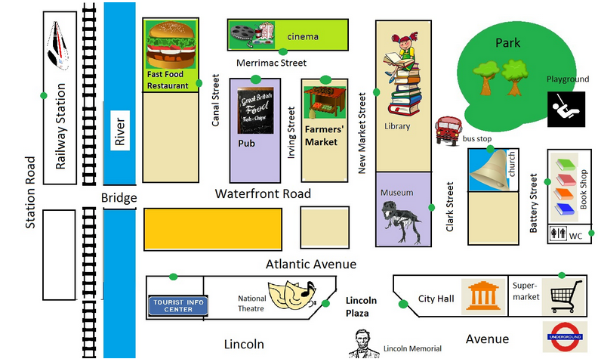

Task 1 – Record a dialogue
Look at the map and make dialogues.
The starting point is always the railway station.
The entrance to the buildings is marked with a green dot.
Follow the instructions below on how to record your dialogue either with Microsoft Surface or your iPad. You can use any other mobile device (smartphone, notebook ...) you want.
Dialogues - Microsoft Surface Textseite
Dialogues - iPad

Task 2 – Make a Video
Choose any place you want to go to on the map.
Start from the station.
Make your own dialogue (and write it down, if you want to).
Follow the instructions below on how to record a video either with Microsoft Surface or your iPad. You can use any other mobile device you want.

Video - Microsoft Surface Textseite
Video - iPad - "ShowMe" Tutorial Video Link/URL
Video - iPad Textseite
Video - iPad - Watch an example!

