Task 1 – A golden ticket for the world of chocolate
- Read the very beginning of "Charly and the Chocolate Factory"!
- Write which place you would like to visit if you found a golden ticket!
- Enter the fascinating world of chocolate and find out about its background.
- Collect information on chocolate.
- Create a factsheet on chocolate.
- Mind the following ideas on how to find information and on how to mind copyright: www.cyberbee.com
- So don`t copy and paste! Use your own words.
- A quiz on chocolate

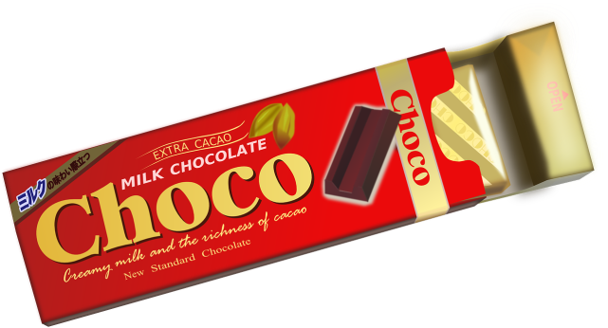
Task 2 – My own chocolate bar
- Use a suitable APP to create your own scrumptious chocolate bar.
- Find a great slogan for it.
- Make a short video to sell your creation.

Task 3 – Book or film? Which medium is more exciting?
- Do you think that a book or a film is the more exciting medium to learn about a story? Vote for your favorite on kahoot.it! Ask your teacher for the game pin!
- Read the chapter on the Chocolate Room. Compare it to the scene in the film. Say which version you prefer and why.
You can read the chapter ONLINE!
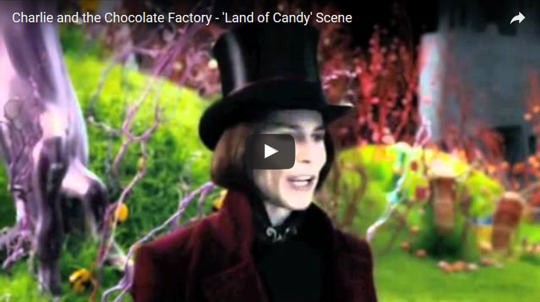
https://youtu.be/5S_AYZGBxkQ

Dave Digital or how to fight Net addicts
In the story Mike Teavee is punished for his addiction to TV. See what happens to him.
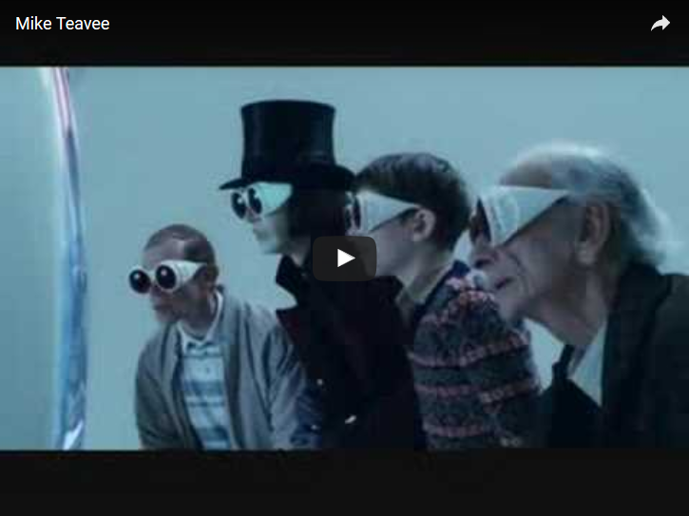
https://youtu.be/RcyyDYucIXk

Continue the story of Dave Digital in which he learns that Internet addiction can be very dangerous.
When Dave Digital switched on his computer, ..........

