Aufgabe 1 – An interview with Jonathan Stroud
Read the interview below!
The Interview: Text version Link/URL
The Interview: PDF version Link/URL
The Interview: Text page Textseite
Listen to a part of the interview Link/URL
Note: The audio file has been produced using natural reader to transform text to speech and audacity to record it.

Aufgabe 2 – Working with Dictionary Apps as „Second Screen“
Helpful dictionaries: All available as free apps
Pons Online Dictionary  Android  iOS  Windows | The Free Dictionary by Farlex  Android  iOS  Windows | Dictionary.com  Android  iOS  Windows

Word Definitions HotPot
Match words and definitions HotPot
Adjektives and Opposites

Aufgabe 3 – Working with Dictionary Apps – Pen and Paper
An Interview with Jonathan Stroud Exercise Sheets Link/URL
Key to the exercises

Aufgabe 4 – working with Mobile Devices – Practice
Note:
To access the material on a mobile device
- start the Quizlet app (or website)
- type "brgsw" into the search field (it is an abbreviation of BRG Schloss Wagrain)
- choose the class "brgsw-dictionaries"
Adjektives and opposites
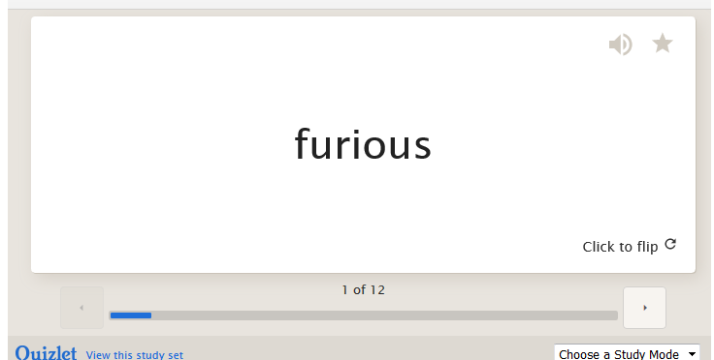
https://quizlet.com/34576831/flashcards/embedv2

Match words and definitions
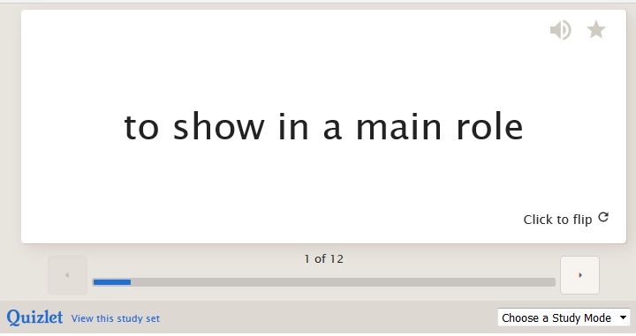
https://quizlet.com/34575855/flashcards/embedv2

