Watch "The Gruffalo". Do not worry if you can´t understand every single word. Try to remember as much as possible!

https://youtu.be/ADqon006eRY

Task 1 – True or False
True or False? Tick the right answer!

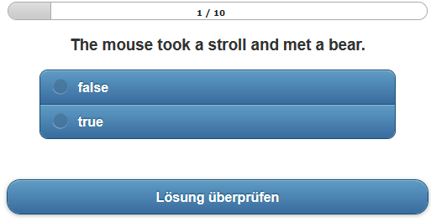
http://learningapps.org/tools/103/8/watch?id=pd2gq6rnt01

Task 2 – Body Parts
Can you remember the Gruffalo´s body parts?
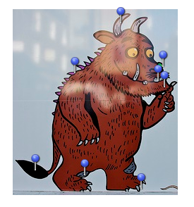
http://learningapps.org/tools/83/6/watch?id=p1ib8d9j501

Task 3 – Create your Animal
The Gruffalo is an animal that does not exist in reality. Create your own animal!
Go to SwitchZoo http://www.switchzoo.com/zoo.htm
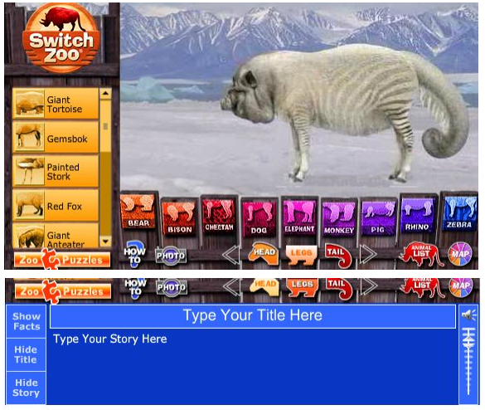
Add a title and describe your animal in the blue box.
Click on "Photo" and copy the picture and the story into a presetation programme (screenshot).
Save the presentation and present your animal to your classmates.
Describe your own animal to your classmates

Record your voice!
Describe your own animal to your classmates - make an audio or video recording.
You can use your smartphone or any other devices that your school offers, e.g. recording software (audacity, vocaroo, office mix, ... )

Listen and compose
Listen to the description of a Gruffalo and try to compose it.

