https://youtu.be/AyTQ7nFN7G0

Your teacher chose CHRISTMAS as an example.

Watch the video and try to remember as many words as possible. They should be used in your "AnswerGarden" :-)

Aufgabe 1 – Working with answer garden
- Click on the following link: https://answergarden.ch/
- Now click on: Create Answer Garden
- Create a new AnswerGarden about Christmas: fill in the topic "Christmas"
- Press "Enter"

Aufgabe 2 – Brainstorm words
Which Christmas words can you remember? Try to find lots more!
Type them in, one after the other.
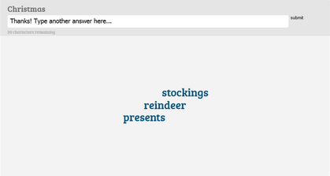

Aufgabe 3 – Creating a QR Code
Click on QR Code...
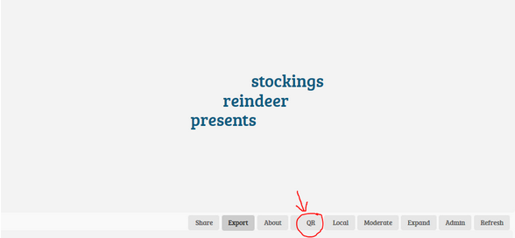

Take out your smartphone and install a QR Code Reader.
Quickly try if it works. Hold your smartphone in front of the field with the QR code above and you'll see all the words that are related to a special US tradition.

Aufgabe 4 – Create a new answergarden to a new topic
You should now work on other types of traditions.
Create a new answergarden.
Create a QR code, save it and print it.
Links for helpful videos:
St. Patrick's Day Link/URL
Halloween Link/URL
Thanksgiving

Aufgabe 5 – Now use your smartphone
Take out your smartphone and scan the QR codes of your classmates.

Create a crossword with an online Crossword Maker
Go to: https://crosswordlabs.com/ and create a crossword about your own topic.
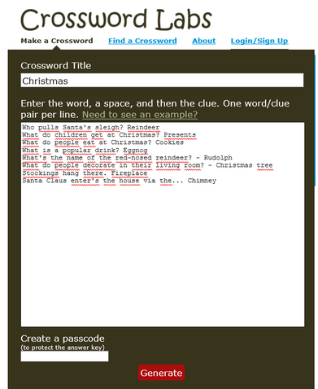
Type in a password to save your answers.
Then, click on "generate".
Finally, save your crossword.

Write your personal book of us traditions
Open a new document and write your own story.
In your story you shoud use at least TEN WORS that were listed in the AnswerGarden.
Make sure you include suitable pictures as well. Find and edit your pictures with http://search.creativecommons.org/.
Click on Open Clip Art Library and enter your search query.
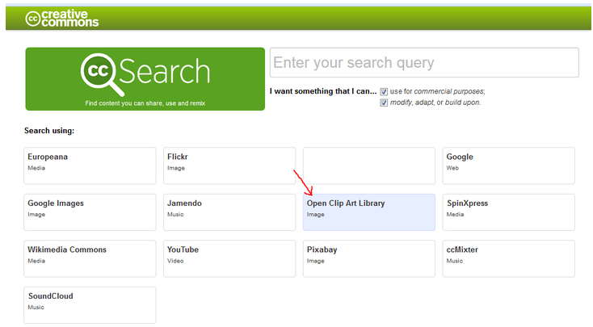
Choose a clipart and click on the button "Edit Clipart".
PERSONAL STORY

