Age group, level of knowledge/skills | K12
Competencies/levels addressed/ teachers remarks | See right column
Timeframe | 200 min (Step 1-4: 2 lessons, Step 5: another 1-2 lessons)  Individual choice of learning paths.
Submit results | Send your results to your teacher via e-mail or your learning platform (Step 1-4) and upload your final essay & evaluate for Step 5 on the Aropä tool.
Objectives of the learning material:
Understand that… there are no irrefutable theories and all studies refers to an specific time and place
Add your answers to this document, including screenshots and useful resources/links.

 | STEP 1: What does globalisation mean?
 | a) Describe your understanding of “globalisation” at the location here: www.goo.gl/aqEXmx .  Use keywords. You will see some examples already there, but don’t feel you have to say the same thing.  b) Check whether these brainstorming results agree with UNESCO’s own definition of globalization, which you can see at: http://www.unesco.org/education/tlsf/mods/theme_c/mod18.html?panel=3#top  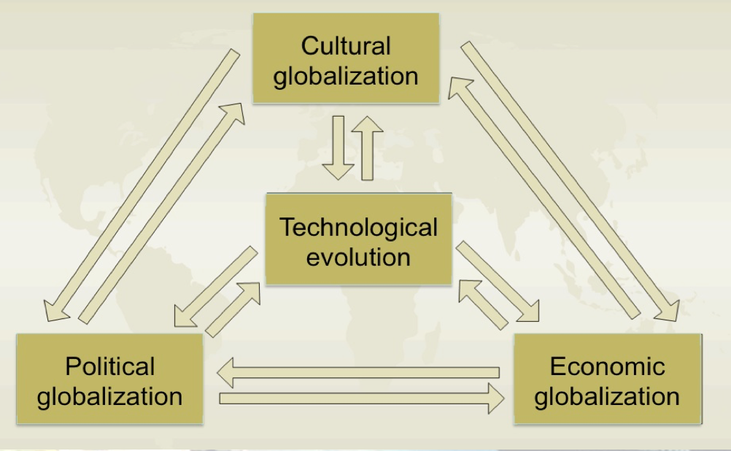  c) Which parts of this definition are new to you?  Conclusion: there are many aspects to the concept of globalisation  d) Group the results of your brainstorming into the 4 aspects of the scheme  - Cultural globalisation  - Technological evolution  - Political globalisation  - Economic globalisation | 5C
 | STEP 2: Explore: globalisation in your daily life and beyond
 | Globalisation in your daily life  a) At home, check whether you have the following categories of products (list as much as possible for each category) and see what was the country of origin.  This is usually found on the product packaging.  If you do not immediately find it, for some products, you can look this up on the internet. For example the products that come from a store like Ikea.  - Clothing (at least 10 different pieces: pants, shirt, sweater, jacket ...)  - Food (at least 10 packaged goods in cans, boxes, ...)  - Electrical appliances (TV, radio, computer, laptop, smartphone, ...)  - Interior objects (at least 10: carpet, chairs, seats, bags, plates, cutlery, towels ...)  - Care products (shampoo, soap, deodorant ...)  - Transportation (bicycle, motorbike, car ...)  b) Go to this Table (https://docs.google.com/spreadsheets/d/1cFCcYyzPrMVNNduyxTtJGDj85aQVrx8GfQTIZQQBkfU/edit) on Google Drive.  Attention: this is a read-only file. To complete this activity, you should log in to Google with your own Google account (if you haven’t got one you can make one). Then download a copy to your Google account. Use this copy to fill in.  Save it as a csv-file (remember where you saved it).  c) Continue this exercise according to this example https://youtu.be/75wv2FTzrJU  d) Compare the results of your class colleagues  e) Combine the results to create a map indicating the hot spots involved in globalisation.  Compare the map the produced with the transport map at: http://arcg.is/2k7tj5w  f) Reflect and discuss what elements make “goods and merchandise” flows possible.  Take note of everything to write a final essay.  Global supply chains (GSCs) have transformed cities, trade and the world economy.  h) Look at this picture: (this is available on page 48 of the document https://www.sc.com/en/resources/global-en/pdf/Research/2015/Global%20supply%20chains%20-%20New%20directions.pdf)  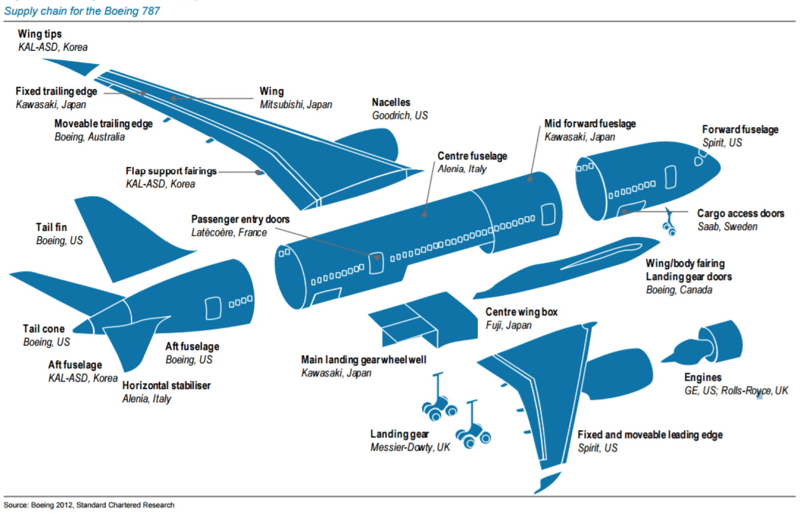  What do you understand by the term “economies of scale”? What do you think it is the scope of them? | 6A,B,C  1A,B,C  4A,B,C  8A  9A  7C
 | STEP 3: Consequences of globalisation
 | Let’s now enlarge the view of globalisation to a world scale using maps  Log in on with your ArcGIS Online account  Search for the map: ‘World trade pattern’  a) Add this layer from ArcGIS Online  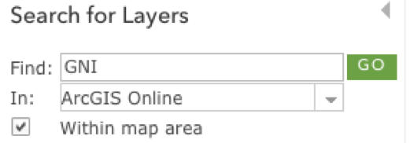  World Bank Gross National Income (GNI) → choose as representation GNI – Per Capita International Dollars  Attention: make sure you are searching in ArcGIS online, not your organization – see the screenshot  Turn these layers on:  o OilShippingRoutes – Major Shipping Routes  o Airports  o Flight Routes  o Global shipping routes  Look at the World overview  b) Describe the results.  Consider the areas of high transport concentration, the areas with few connections.  Identify the main connected cities… take note of these for the final activity.  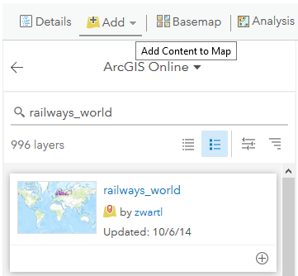  c) To get information on the ‘network society’, in the map on ArcGIS Online:  uncheck ‘World Bank Gross National Income (GNI)’  add these layers (zwarti as the author):  o roads_world → choose as colour for the roads red, size 1 pixel  o railways_world → choose as colour dark grey, size 1 pixel  o world urban areas → set visibility range: show this layer only when zoomed at least scale 1/150.000.000  If you get the message ‘Layer did not draw completely’ this because it is too extensive: select ‘Don’t show this message again for this layer’ and click OK.  d) Zoom in to North-America, make a screenshot (with the legend/key) and describe the pattern.  e) Zoom in on Africa and repeat this  f) Select the layer ‘Global Accessibility Map’ and explain the colour code  We will now enlarge the view to a world scale using statistics in graphs  g) Watch the video: 200 Countries, 200 Years, 4 Minutes  https://www.gapminder.org/videos/200-years-that-changed-the-world-bbc/#.VEQc68m7WSo  h) What conclusions can you bring to your final essay?  Does globalization affect all countries equally?  Does the economy grow at the same rate in all of them?  Which countries are staying behind? And which ones are in the vanguard?  You can also look for other graphics and visualisations to help you organise your conclusions, for instance: http://www.pcanete.com.ar/hans-rosling-gapminder | 5C  7C  8B,C  9B,C  2A,B,C  2A,B,C
 | STEP 4: Reflection: What about sustainable development?
 | a) Does sustainable development deal with globalisation? See http://www.un.org/sustainabledevelopment/ and/or http://www.un.org/sustainabledevelopment/sustainable-development-goals/  The UN suggest a “roadmap” for sustainable development.  What do you think about such a roadmap?  c) Consider and discuss with others the advantages of this “roadmap” vs. a single goal “sustainable development”.  d) Does the Human Development Index (HDI) show globalization in reality?  e) Explore the map by countries paying attention to the most developed country in the world and how is your country compare with it: http://hdr.undp.org/en/countries  f) Does (global/local) development need to be planned? If yes, WHO should be in charge of this? | 10A  10A  7A,B,C  3A,B,C
 | STEP 5: Sharing: Globalisation - Advantages and Challenges
 | a) Produce an essay on the topic: Globalization: Advantages and Challenges  The essay should consist of a logical argument or reasoning that exposes the importance of the themes and aspects to defend. In this particular case: it is ‘advantages’ and ‘disadvantages’ of globalization.  In your essay is possible to pose questions and reflections, no solutions are asked for, you should also (critically!) use various materials and sources of information.  Formal rules: Create a text document (Word, pdf or open), write your essay on Calibri font size 11. The essay should be a maximum of 7000 characters with spaces, or one A-4 sheet on both sides.  The main points to take into account to elaborate the essay and to evaluate other essays:  - Think about a title for your essay.  - Provide relevant information on the topic, discuss the pros and cons at different levels of scale.  - Make a coherent discourse, clarity of ideas and argumentation, adding a personal contribution/your opinion.  - Suggest new questions and reflections on the subject that opens bridges to further discussion.  - Content, spelling and grammatical expressions should be accurate.  - Use an impersonal style or write in the third person - except of course for your own opinion ;).  b) Share your work with other students by double blind review on an online tool following these steps:  Go to Aropä: http://aropa2.gla.ac.uk/aropa/aropa.php?action=login&at=34  Username (given by your teacher, only one word with no capitals, no accents...)  Password: GI (See that the first time you connect the system will ask you for a new password)  Thus, it is necessary to:  1. Upload before (date to agreed) your essay on the previous URL  2. After all the students have uploaded their own essay, you can review other essays  3. Give your feedback using the criteria below: Rubrics for evaluation of the essays:  1. Meets the standards of the requested work  2. The title chosen is attractive and according to the centered  3. Provides key information on the topic  4. The theme or aspects developed are correctly focussed  5. Contains a personal contribution  6. Suggests new questions and reflections on the subject that opens bridges to further discussions.  7. Has accurate content, spelling and grammatical expressions  8. Use an impersonal style or written in the third person  9. What is your overall opinion of the work?  Poor: inadequate, shows a lack of understanding.  Just adequate: some gaps  Good: covers most things  Very good: covers everything, comprehensive  Outstanding  Justify your mark  10. Did you enjoy reading the work?  11. Other observations you would like to add  12. Summarize in a sentence what you learnt when reviewing this essay. | 10 A,B,C  It is advisable for teachers to read  Aropä users guide: http://www.dcs.gla.ac.uk/~hcp/aropa/AropaGuide.pdf  There is also available a FAQ document:http://www.dcs.gla.ac.uk/~hcp/aropa/AropaFAQ.pdf  Teachers should set up a group for the students to share their work.

Use this document to add your comments.

