  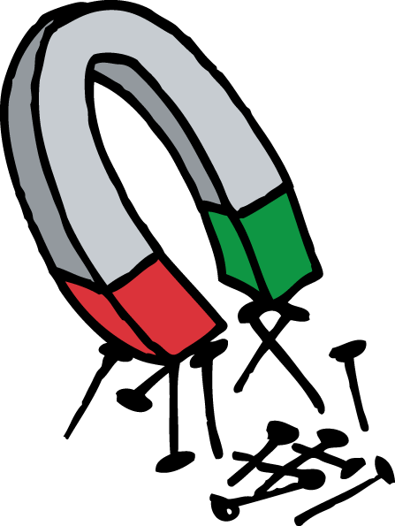  Sachunterricht  Paula Musterfrau  1A2014/15 | 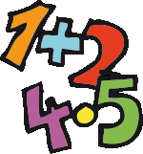 | Sachunterricht  Paula Musterfrau  1A2014/15
Sachunterricht  Paula Musterfrau  1A2014/15 |  | Sachunterricht  Paula Musterfrau  1A2014/15
Sachunterricht  Paula Musterfrau  1A2014/15 |  | Sachunterricht  Paula Musterfrau  1A2014/15
Sachunterricht  Paula Musterfrau  1A2014/15 |  | Sachunterricht  Paula Musterfrau  1A2014/15
Sachunterricht  Paula Musterfrau  1A2014/15 |  | Sachunterricht  Paula Musterfrau  1A2014/15

