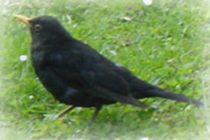

Name: ________________________

Wohnort: ___________________________________________________________

___________________________________________________________________

Familie: _____________________________________________

Größe: __________ cm

Mein Federkleid

Männchen: __________________________________________________________

___________________________________________________________________

Weibchen: __________________________________________________________

___________________________________________________________________

Lieblingsspeisen: ____________________________________________________

Was du über mein Nest wissen solltest: ___________________________________

___________________________________________________________________

___________________________________________________________________

