Crossword Puzzle

Print the Crossword Puzzle out. Then, have a look at the sentences and hints below and try to complete this Crossword Puzzle. You will find all the information you need on the following web page: http://www.iloveny.com/kids/index.asp Further key words concerning state symbols can be found under: http://www.wordle.net/show/wrdl/3007909/Untitled

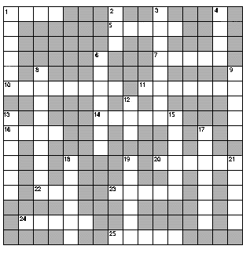

Down
1. State fish live in freshwater ____, lakes, and streams
2. The ____ scallop is the state shell
3. State bird
4. State flower
6. Largest city in New York State
8. State motto
9. Maple ____ comes from the state tree
12. The state fossil is the ____ scorpion
13. New York is the '____' state
15. State capital
17. Golden Delicious, McIntosh, and ____ are varieties of the state fruit
18. Longest river in New York State
19. State animal
21. There are almost 1,500 ____ and villages in New York State

Across
1. Colour of state bird
5. State muffin
7. Bird of state arms
10. Number of counties in New York State
11. ____ and Justice are two symbols on the state arms
14. Largest lake in New York State
16. State beverage
20. State gem
22. Colour of state gem
23. Highest mountain in New York State
24. Type of boat found on the state arms
25. State fish

