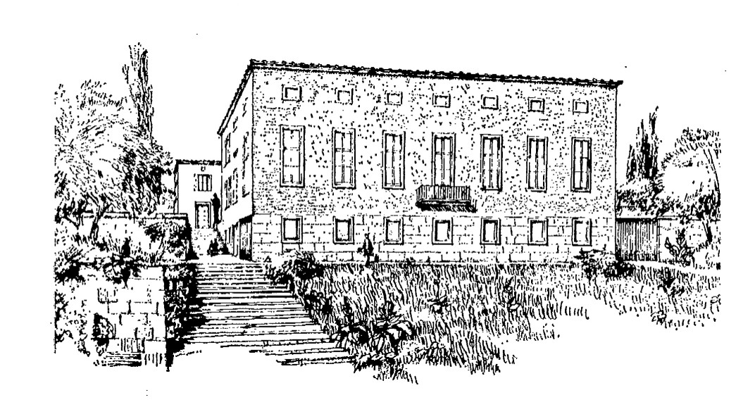

Istituto Svedese di Studi Classici a Roma
Stiftelsen Svenska Institutet i Rom

Academia Latina 2006

Tue1/8 Arrival: Dinner and welcome at the hotel

Wed2/8 Am 9-12 Lessons at the Swedish institute

Livius Ab urbe condita: I. 7-13 passim: stories from the early Rome and preparation for visit of Forum and Capitolium( Eva )
Beginners’ Italian(Carlo )
History of republican period
and preparation for Palatium( Serena)

Pm Capitolium , Forum Romanum,

Thu 3/8 Am 9-12 Lessons at the Swedish institute
Petronius: Satyricon XXII, XXIII,XXXIV,( Serena )
Italian (Carlo)
History of early imperial period (Eva )+preparation for visits (Barbara)

pm Pantheon ( Barbara) + Fori Imperiali ( Barbara),
Fri 4/8 Am 9-12 Lessons at the Swedish institute :
Plinius 6:16, 6:20: Eruption of Vesuvius (Serena)
Horatius: Iter Brundisinum( Carlo)
Painting and sculpture( Barbara )

pm :Visit to Palazzo Massimo, (Barbara)

Sat5/8: Lessons in the Villa Borghese park( Eva , Carlo, Serena)
Ovidius Metamorfoses: Apollo et Daphne, Proserpina .
Translation and reading in mother tongue and preparing for a show the last night

Visit to the Galeria Borghese ( Barbara)

Sun 6/8, 7-22 Pompeji , full day excursion

Mon 7/8 am 9-12 Lessons in the Swedish Institute:
Martialis 1.19, 1.38( Serena ),
Italian (Carlo)
History of Flavian emperors and preparation for visits( Eva)

pm Colosseum( Carlo) , Palatine ( Serena)

Tues8/8 am 9-12 Lessons in the Swedish Institute:
Trajanus and the emperors further on (Serena)
Italian( Carlo),
Plinius:X. 96-97: Letter to Trajanus concerning the Christians ( Eva )

pm Via Appia( Carlo), catacombs( guide)
Dinner , performances of Ovid and closing of the course

Wedn 9/8 Departure

