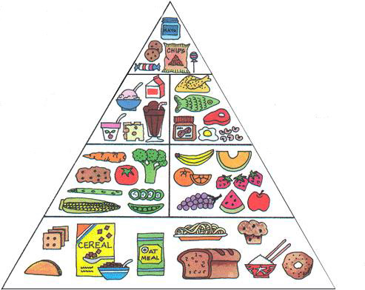
FOOD PYRAMID

______________________________
use sparingly

________________________________ ______________________________
2-3 servings 2-3 servings

___________________________ ________________________
____ servings _____ servings

________________________
____ servings

