Report and evaluation from Academia Latina III

For the third time we successfully arranged an Academia Latina in Rome. The aim of the school is also one of the most important aims of EUROCLASSICA, to make pupils and students aware of the European dimension of Classics. The summer school brings together young people from different European countries around a classical theme. This year’s theme was “Panem et circenses”. Combining lessons with instructional tours to museums and archaeological sites provides a practical as well as a theoretical approach.

On the 2nd August I finally managed to gather all student participants of this year’s Academia Latina, just a few minutes after the closing of the gates of the monastery. Poor Liesbeth Berkvens, was finally let in by Padre Matteo. She had waited the whole day for everyone in the airport when she came with the last students and had special permission to get in for the night. This year we lived in the monastery Padre Teatini, San Andrea della Valle. Padre Pietro who took care of us the rest of the week was very helpful and friendly.

Due to the monastery’s cleaning hours we had to rearrange the schedule and make the visits in the morning, so we started by visiting Capitolium, Theatrum Marcelli and Circus Maximus. In the afternoon we had lectures and seminars on panem et circenses, politics and history , the visits next day ,and translation of Iuvenalis. Barbara Pokorna arrived for dinner and the team was complete.
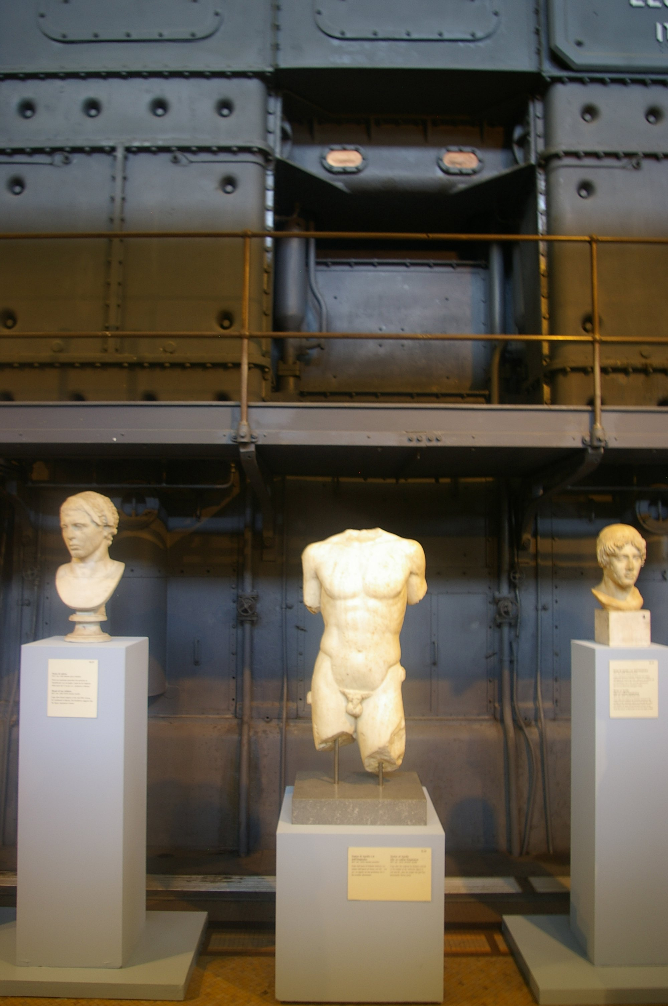
The following days we visited Forum Romanum o Fora Caesarum , Colosseum and the Palatine hill, Villa and Galeria Borghese, Villa Farnesina, Isola Tiberina, had a long walk on Campus Martius visiting Ara Pacis, the mausolea of Hadrianus and Augustus, Pantheon, Piazza Navona, Campo dei Fiori etc. We also visited the Collection of the Capitoline Museums at the Montemartini Power Plant and after that a small group also went to see the San Paulo fuori le mura.
In the afternoons we studied and translated texts from Ovidius, (Ars Amatoria and Metamorphoses), Horatius , (Ibam forte via sacra and Carmen Saeculare), Augustus (Res Gestae) ,had lectures on Art, Architechture, and everyday life.
In the evenings we had nice dinners in different parts of Rome, sometimes the whole group and sometimes in smaller groups to give the the students time and opportunity to explore the eternal city on their own.
The last day, on the 10th of August, we made a whole day excursion to Ostia, where the students also performed plays (based on Metamorphoses or Ibam forte) in the theatre and finally we went swimming at Lido di Ostia, where one group performed. In the evening we had a nice closing dinner and said good bye, threw coins and took many pictures in front of Fontana di Trevi, promising to stay in touch. Already the next day there was a group on Facebook where everybody could chat, stay in contact and download their pictures! To see some pictures, look at the new website of Academia Latina www.academialatina.eu .

Some quotations from the evaluation:

I just want to thank you once more for the fantastic unforgettable week in Rome!for everything you've done!

I would like first to say thank you to you, Liesbeth and Barbara. It was a really nice time in Rome, I learnt a lot and I met very wonderful people. I don't have anything to complain and I think is a good idea to do the visit in the morning because of the hot. The rest was really good for me and I hope everybody enjoy the trip.

The programme was good, with the monuments and the texts etc. a good mix.
My main concern was with not having enough time for Rome ( curfew at 23.00) and the afternoon lectures, they were a bit too squished together. you couldnt really go into much detail or depth.

I just wanted to email you to thank you for the wonderful time you gave us last week. I have fallen in love with Rome and am incredibly upset to be back in Scotland. You, Liesbeth and Barbara taught me so much about latin and the classical world which was fascinating, so for this i am thankful. I really had the best time with you and the rest of the group. think the visits in the morning is a good idea. also i thought the lessons were an appropriate length, i really liked the way we did translation. i really have no suggestions for change, i thought the whole thing was well structured and a lot of fun. i loved the texts we studied too.

So, I dare to say we have been successful, and that we intend to improve and keep on working to arrange the Academia Latina IV in 2010, circumstances permitting.
My colleagues and I are happy for the opportunity to have met and got to know these fantastic, unique students for some days, to show them Rome and unite in the study of our common European heritage.

Eva Tarandi,
Director and president of Academia Latina
representative of Sweden, Svenska Klassikerförbundet

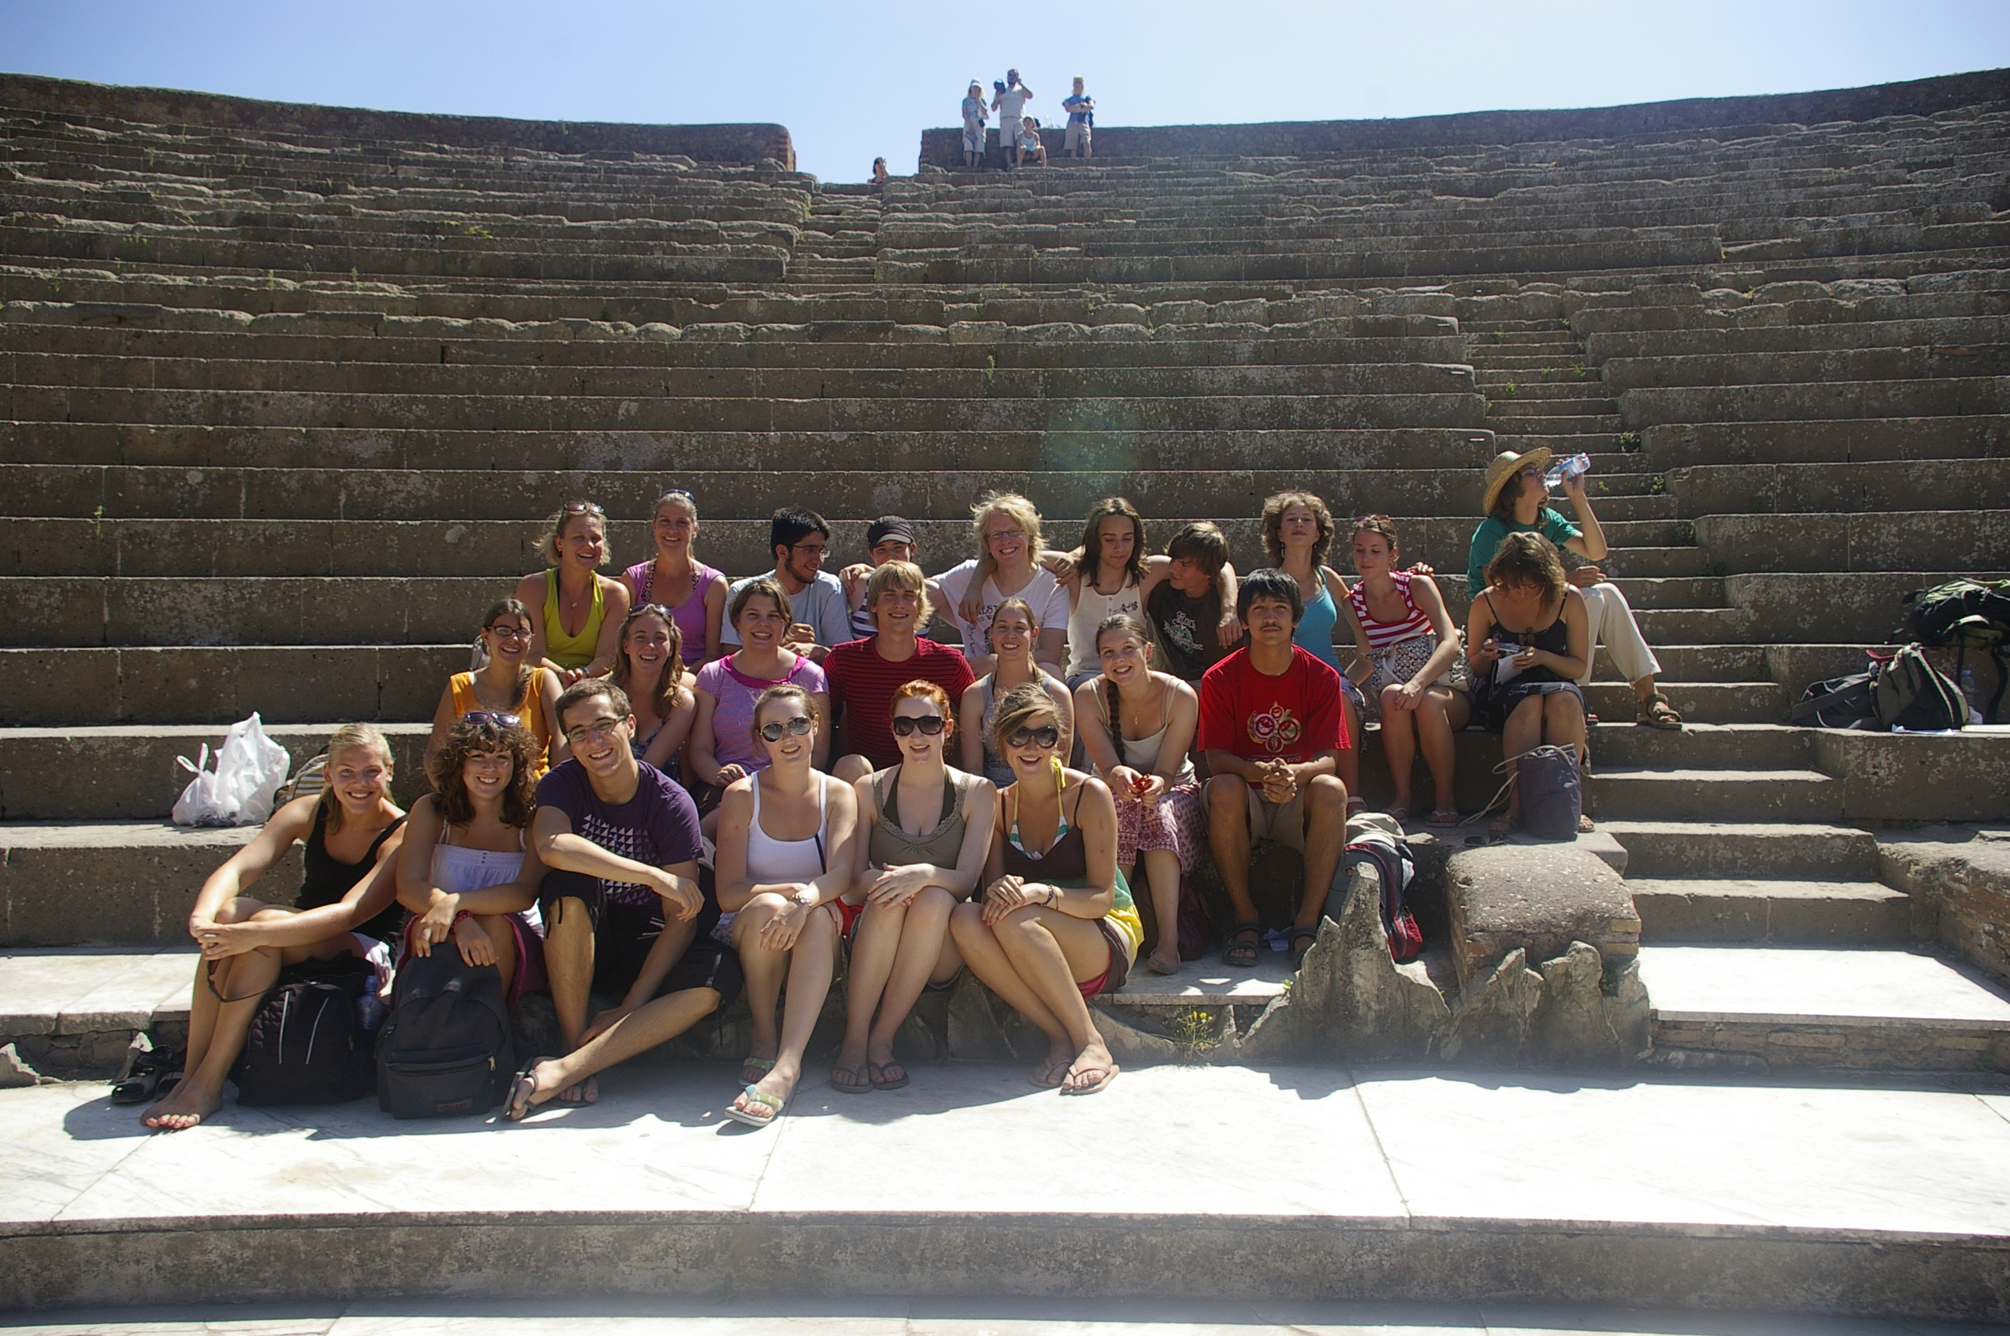
The whole group with Eva and Liesbeth in the theatre of Ostia.

