Academia Latina secunda, 1-10 augusti 2006

Finally it could take place, Academia Latina Secunda But 2002 the former executive committee tried but without enough applicants we could not run. But two years ago the Academia Latina prima could take place and this summer again, in cooperation with the Istituto Svedese a Roma, with the theme ” The city”, enough students applied and the school was actually to take place a second time!
On the 1st of August we all arrived in hotel Mimosa just behind Pantheon. This year we stayed in a hotel, which was very central but unfortunately had no rooms for teaching as we had last time, staying in the guest house of Trinità dei Monti monastery, just above the Spanish steps, which this time was fully booked. But thanks to the cooperation with the Swedish institute we could realize this year’s summer school. The only problem was that we had to spend a lot of time travelling to lessons, but it was better than not being able to do it at all.
The 23 participants this year came from Croatia, Spain, Austria, Switzerland, Russia, Sweden, Belgium and Portugal.
The routine of the days was mostly teaching in the Swedish Institute in the morning and visits to monuments and museums in the afternoon. One of the students remarked it would have been better to do the other way round so we will discuss how to get the most of the days. Maybe we hope to have another lodging next time a do not have to spend time travelling to school every day.

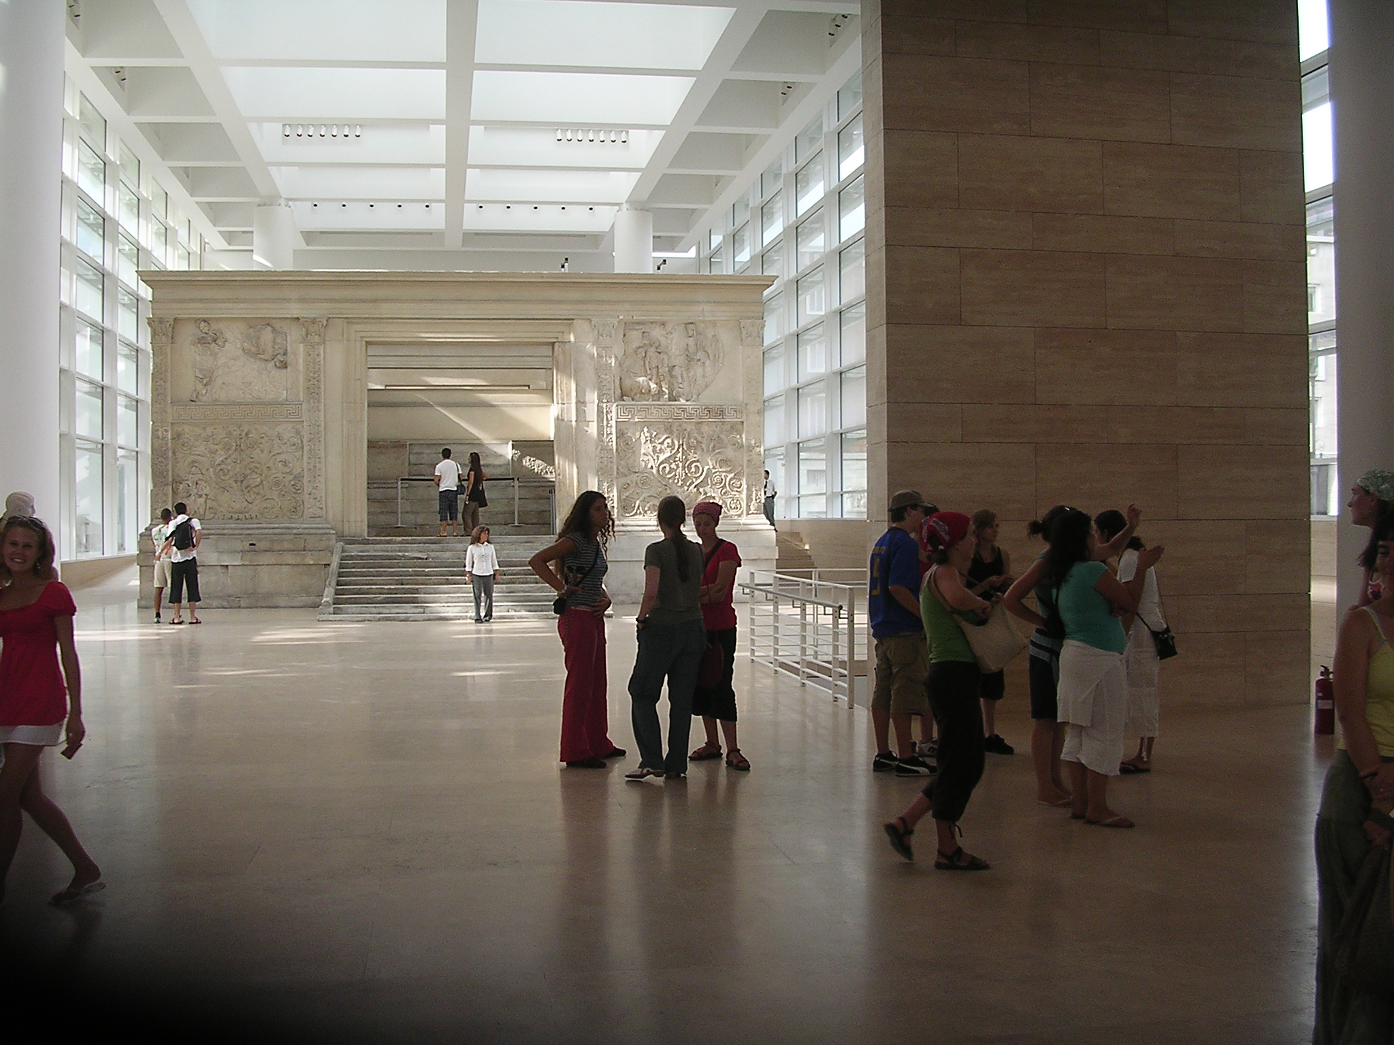
.
Ara pacis Augustae, the newly built museum in Via Ripetta, Lungotevere

The first morning we read and translated a little of Livy, had a lecture of the history of the republic and an Italian lesson. In the afternoon we split up in three smaller groups Eng/ Eng/ French to visit Capitolium and Forum Romanum. After that many wanted more, so almost the whole group visited the in April newly opened, controversially modern museum building of Ara Pacis.The Thursday was about the same, lessons in the morning, e.g. Petronius and early imperial history, in the afternoon Pantheon and Fora Caesarum. We also tried tofind Forma Urbis Romae by the Forum Pacis e. g in SS. Cosma och Damiano without result, nobody could tell us for certain where to find it.
Next day was Horace, Iter Brundisinum, Pliny on Vesuvius and art, everything to prepare our Sunday trip! Palazzo Massimo with the exceptional collection of mosaics and fresco wall painting was the afternoon target,

Saturday morning sleeping a little longer was allowed. The lessons where in the Villa Borghese Park and three different Metamorfoser were studied. The rape of Proserpine,Apollo and Daphne and Perseus. First some reading and translating, then smaller groups prepared to perform and act something from these texts. And this was to take place in the great theatre of Pompeii. And why study Ovid’s Metamorfoses in theVilla Borghese park? Well of course to experience the outstanding sculptures of Bernini! A small group of teachers and students still hadn’t had enough, so we went to the Crypta Balbi and guess what we found there: a part of Forma Urbis!

So, Sunday was the day of Pompeii. The bus picked us up at Piazza San Andrea della Valle just before 7 o’clock and at 10.30 we already were in Pompeii. The day was hot and tough but in the end it was pouring down. Sasha from Russia took a shower in the street before eating, when the rest of us sat safely inside a restaurant, resting exhausted, waiting for food. But Pompeii is always worth the trouble!

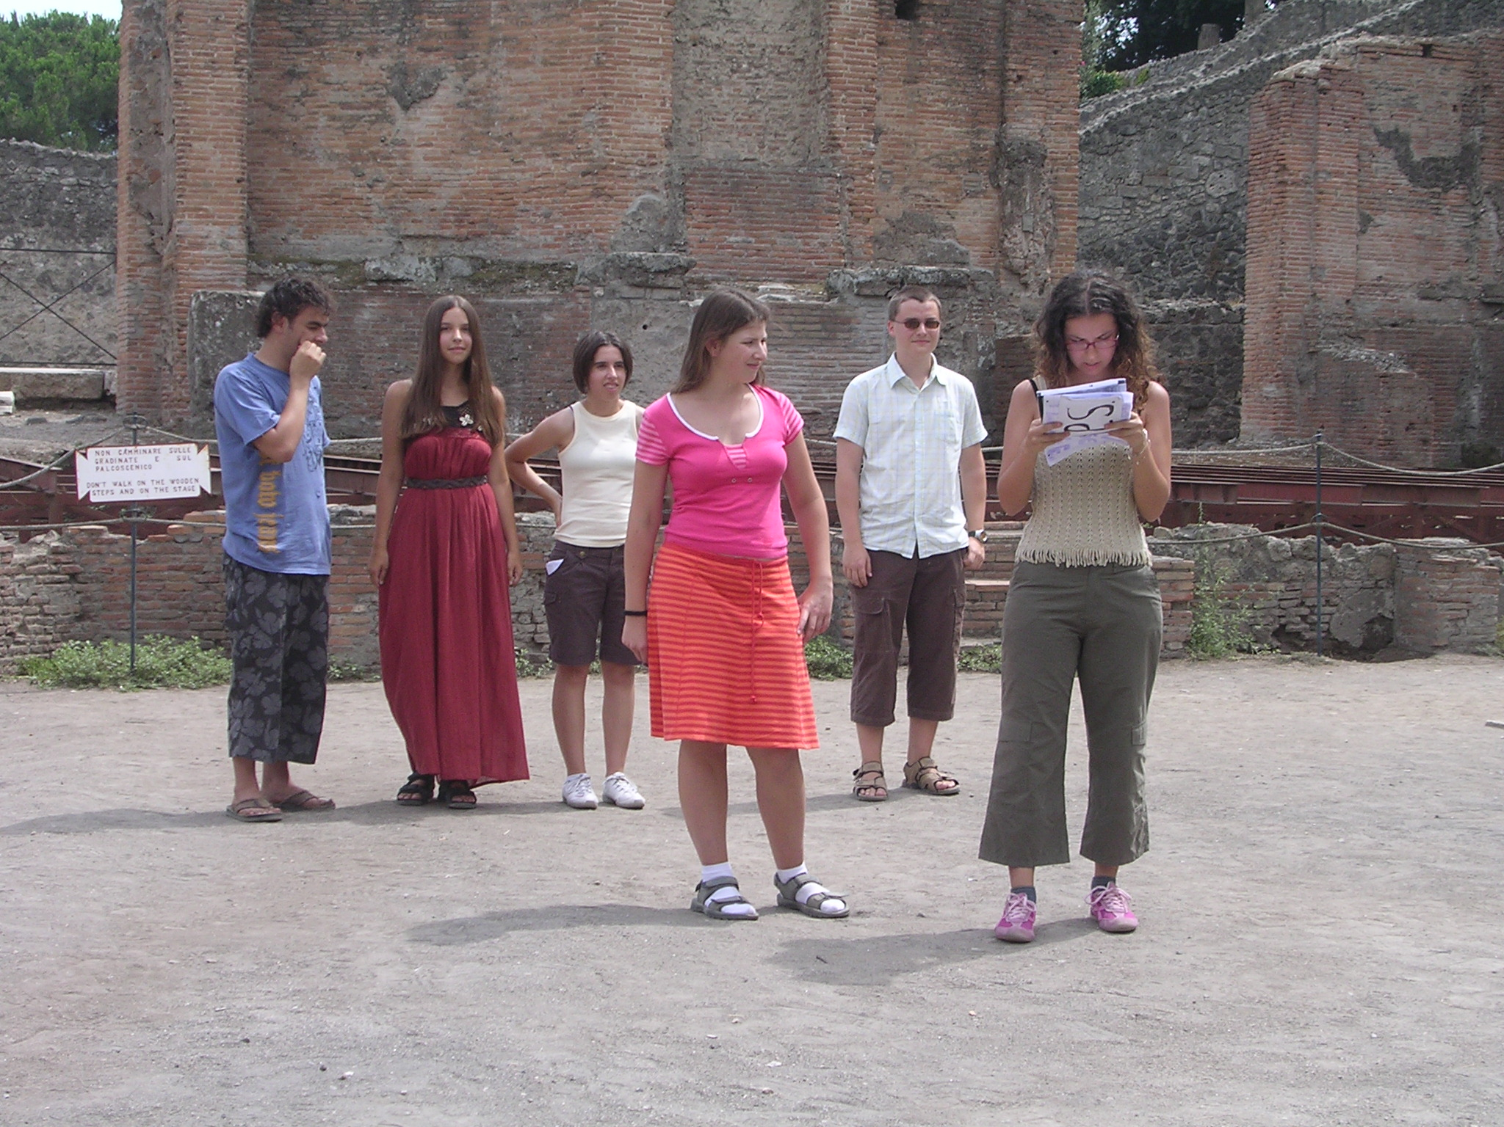

In the great theatre of Pompeii pupils from Portugal, Russia, Spain and Austria performed “Perseus”.“Need a hero, call 911 Perseus private line”!
One of the most important aims of Euroclassica is to make pupils and students aware of the European dimension of Classics, as our common “mother tongue” and cultural roots ,and bring together young people from different European countries around a classical theme and the performances of the students really showed nice examples of international cooperation!

We also managed to visit among other things the Palatine, Colosseum, Via Appia and Catacombs, study some more texts, e.g. Martialis and more Italian and History of course but above all the students got very well along and were close friends by the end of the course so thath nobody wanted to go home!

Some cuts from the evaluation:
What was the best about Academia Latina according to you? “Everything was great: classes, visits, friends, even pasta everyday!”” To visit beautiful ruins with very good explications, we can tell some questions and have all the answers!!!”” I think the best thing was that we had the chance to meet young people from all around Europe with interests similiar to ours and to spend a great time together in one of the most beautiful cities I know.”
” For me, the best of Academia Latina was the theatre in Pompeii!
It was really funny, even if I think we did not have enough time to prepare it.
What is your opinion about the lessons?” I think the historical lessons before the visits were important. But concerning the language lessons, I think that we could translate
in english , like we did, for everyone to understand but we should read more in our own language.”” The lessons were very interessant, but we were on holiday and sometimes it's difficult to be concentrate during the lessons but three hours this is nothing.
And when we accepted the travel we know that we have some lessons. I think the lessons were very good.”” I think the lessons were very interesting, I liked the mixture of latin, history and italian, but maybe I would have liked to have a bit more advanced
italian for those who, like me, have already learned it at school...”

What is your opinion about the organisation of the course? “Everything was fine.”
“The courses were good organisate!!!”” I think the organisation was great, you did a very good job.. One last thing I want to suggest, but I know that you had planned it like that anyway, is to have lessons and accomodation at the same place, because it always took
us so long to get to the institute, and this also made it neccessary to get up a bit early..”” After the first day, the organisation of the course was good but it is to bad to be inside in the coolest part of the day and visiting monuments when it is boiling hot outside.”
Any ideas of improvement? “Yes. As Serena and Carlo sing so well, I think that 10 minutes ofthe italian class should be about a song (their choice). To start I
suggest "Vento sotille". =)” “ I haven't any ideas because for me it was perfect so thank you very much, thank you for all!!!”” If the course could be longer, it would be really good because we do not speak to each other before one week (even if we try to speak before) and it is really sad.”
Further comments. “No further comments. I just loved it.”” All in all I really loved Academia Latina, and I hope you'll be able to do it again in the future!”” The course was very good and I really enjoyed it. If I do not come the next time, my brother will surely go.
Please continue doing that, it is really worth it!”

Il gruppo 2006
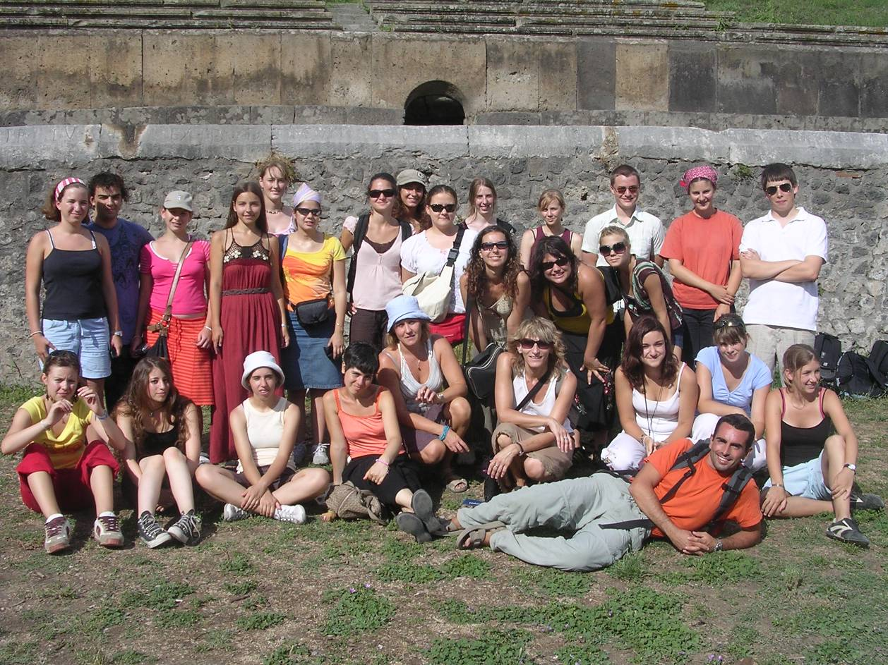

In the middle of the picture the teachers: The writer of the article as well as Director and Organizer of the Academia Latina in a blue hat, flanked by Serena Ferrando, Italy and doc,Barbara Pokorna, Czech republic ,and lying in front Carlo Bavastro, Italy.

Eva Schough Tarandi, Sweden,
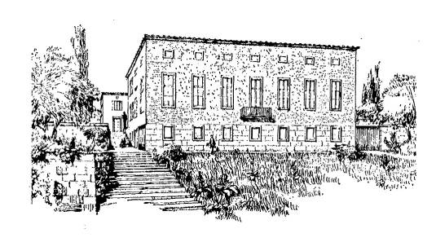
Istituto Svedese di Studi Classici a Roma
Stiftelsen Svenska Institutet i Rom

