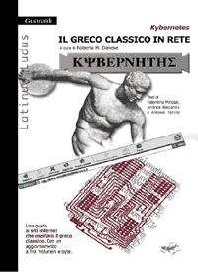
Kybernetes

Il greco classico in rete (The classic greek in the web)
Una guida ai siti Internet che ospitano il greco classico (A guide to the websites hosting classic greek)
Con aggiornamenti di "Tra 'Volumen' ebyte" (With updates of "Between 'Volumen' and bytes")

Edited by Roberto M. Danese

Book Index

Foreword: contemporarypeople of the future
ChapterI: how to visualize ancient greek alphabet
ChapterII: the digital libraries
ChapterIII: research (philology, papirology, etc.)
ChapterIV: didactics of greek
ChapterV: curiosities

Guaraldi Editore, Rimini, Italy
003954152120

Give back to commerciale@guaraldi.it

Editions Guaraldi
V.le Spica 1
47900 RIMINI

1.I would like to receive ______ copies of

TRA 'VOLUMEN' EBYTE

Retail price euro12,00 paper (plus shipping)
Digital file price euro 7,20

2.I would like to receive ______ copies of

KYBERNETES
Retail price euro 15,00 paper (plus shipping)
Digital file price 9,00

I would like to pay via:
-payment to an Italian postal account, 35783885
-payment to a bank account at the Banca Popolare Emilia Romagna-Sededi Rimini ABI 5387 CAB 24201-6c/c Guaraldi Srl 1132175
-check/cheque made out to GuaraldiSrl

Name:
Address:
City:
Country:

