Euroclassica community Denmark at http://www.schule.at

Community-Tool at schule.at

Guideline and short descriptions of functions
Status 18.11.2005
Communities are virtual group rooms which support the flow of information and communication in working groups (f.e. regional group of colleagues for a subject or teachers of a school) and learning groups (f.e. school classes/students and their teachers).
This tool supports group-oriented working over the internet, such as it is the case in working groups, schools or classes.
Communities at schule.at are for free when they are used in public educational institutions.

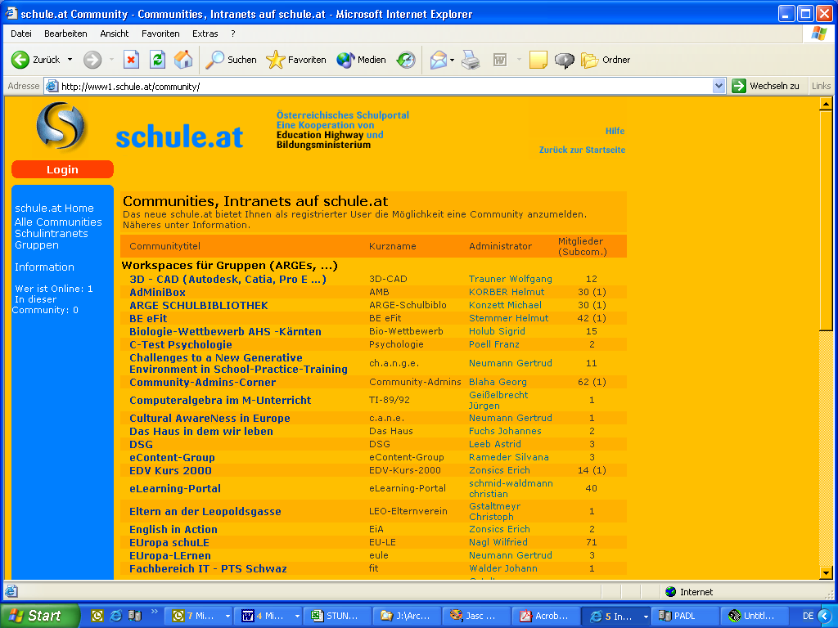

schule.at – list of available communities

Codes for designing and linking within modules
In the modules “forum”, “news” and “resources” you can use following codes for designing and linking:

[url]http://www.website.at[/url] http://www.website.at
[url]http://www.website.at|linktitel[/url] linktitle (links to http://www.website.at)

[img]logo.gif[/img] Bild (Adresse: logo.gif) without alternative text
[img]logo.gif|Logotext[/img] Bild (Adresse: logo.gif) with alternative text Logotext
[b]BOLD[/b] BOLD
[i]cursive[/i] cursive
[red]red font[/red] red font
[blue]blue font[/blue] blue font
[green]green font[/green] green font
[grey]grey font[/grey] grey font
list: [ul][li]apple[/li]
[li]pears[/li]
[li]lemons[/li][/ul]
outcome:
- apple
- pears
- lemons
numeration: [ol][li]apple[/li]
[li]pears[/li]
[li]lemons[/li][/ol]
ergibt:
- apple
- pears
- lemons

TIP:
If there is no site loaded after more than 10 minutes you will be logged out automatically. (common internet-browser-problem)
This is the case when you write a long text for a long time. It is advisable to write long texts offline and copy the text into the text field.

The Community-Tool offers following modules:

- Resources
This module allows the administration of different resources. You can collect links or administrate data. Each entry can be described and provided with a little symbol. This is an example of the working group “Denmark”. This resource module is provided with the title „Applied Classics“:

resources (different types of documents)
When you click on an entry – if it is a hyperlink into the www – the website will be shown in a new browser window. If it is data to download from the schule.at Server, you will be asked where to store this data on your PC - or the program you need to show this data will start. This data is available for further adaption.
- News
Through this module you can publish news. These entries are structured in title, short text and long text. Each entry can be scheduled by the input of an appearance and an expiration date.
news entries

When you click on the title of the news module you can see a list of short messages (news) with subject, date and author in the left big frame.
If you click on “more…” you can see the whole content of the news. Only the administrator of the community and the members of a community can write short messages. Administrator is the person who applies for a community and has the right to administrate as “owner”.

- Forum
In the forum you can open discussions to any themes. You can discuss if you are a member of your community. You can also underline your opinion through little symbols.
discussion forum
You can open a new discussion thread when you click on “new entry” or you can participate in an existing discussion topic. When you create a new topic you can fill out your topic in a form and under it your first discussion contribution.
With a click on “submit” you publish your contribution.
All thread titles are shown according to their date, all reply-postings are shown if you hit the thread titles. (There is either a thread view or a board view)
You can reply on a contribution if you click on “post reply”.

Calendar
The calendar module simplifies the administration of dates. You can declare title, short description, place and time and a contact person with mail address and URL. All dates are sorted automatically and are invisible when your date is over. All dates can be seen in the archive.
dates in the calendar

How to create a date:
After starting the calendar module you can click on “make a new entry in the calendar” and see the form for a new date.
You have to fill in “title”, “description”, “beginning day” and “end day”.
After expiration the date will be archived automatically.
To use an archived date again click on “archive” on the right frame and update your data.

- Gallery
This module offers the possibility to show a picture gallery. Each member of the community can upload new pictures. When you upload a picture a thumbnail will be generated automatically. When you click on this thumbnail you can see the picture in large size.
There is also the possibility of a slideshow, which starts in a new window. In this slideshow you can adjust the duration of changing the pictures. Furthermore there are buttons for break (stop slideshow), start (start slideshow), forward (show next picture), backward (show last picture), beginning (show first picture) and end (show last picture) available.

Picture gallery with thumbnails of all pictures

Slideshow (automatic presentation of the pictures)

- Guestbook
In the guestbook you can publish entries. It is a feature to get feedback of the users even if they are not members of the community. Each entry has a title and a text. Anonymous users can publish their name and e-mail address additionally.

guest book entries

User administration
Each registered schule.at-User can create and administrate a community.
You have to be logged in to see the menue “new subcommunity”.
Within one day this community will be activated.
Administrator of the community is the person who created the community.
Members of a community can also be non-registered persons at schule.at
(extern users).
The list of members is only shown to users which are logged in.

list of community members

The administrator of a community can assign following rights to each user:

- All internet users can read content, which are not internal.
- Members: can read all entries and can discuss in discussion forums.
- Authors: can add entries and can edit/delete own entries.
- Editors: can add entries and edit/delete all entries, even entries of other users.
- Administrator: has the rights of an editor and administrates all users and directories.

Newsletter
With the module newsletter you can offer information for the members of your community in an easy and quick way.

create a new newsletter
To create an internal community newsletter click in the left frame on „newsletter“ and fill in subject and content. You can also attach documents, just click on “search” and choose a document. If you don´t with to save the newsletter in the archive – disable the checkbox „Save e-mail in Newsletter Archive“.
With a click on “send e-mail“ you send the newsletter to all members of the community.

Who is Online?
With a click on “Who is online” in the left navigation frame you can see a list of all users which are logged in. “Online within this community“ constricts the list of the community members which are logged in. You can contact all online-users via „send message directly“.
list of members who are online

Subcommunities
To each community you can create subcommunities, where students/pupils can work within virtual learning groups in the community.
Subcommunities have the same functions as communities.
When you click on “new subcommunity” you get the form to fill in. After registering of the subcommunity you can activate it with a click on the menu “administration” “subcommunity management” and “activate”.
With click on “change” you can rename or delete the subcommunity.

Planned extensions
The community tool is constantly extended through more features and modules. Following modules are planned in the near future:

statistics-module to see the access to the community

directory-module to group each module for a better overview.

chat-module

Contact
For support for technical problems please contact us via a.thiel@eduhi.at or peter.glatz@eduhi.at .We will be at your disposal in case of any problems.

