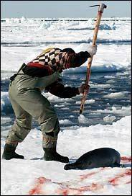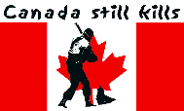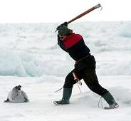

BLOOD ON ICE - CANADIAN BABY SEAL SLAUGHTER

Blood on ice – Canada’s bloody maple leaf of pain
Little dying corpses on the floes in horrific stains
An Atrocity of cruelty to have young seals bleed
To subsidize merciless sealers unscrupulous greed

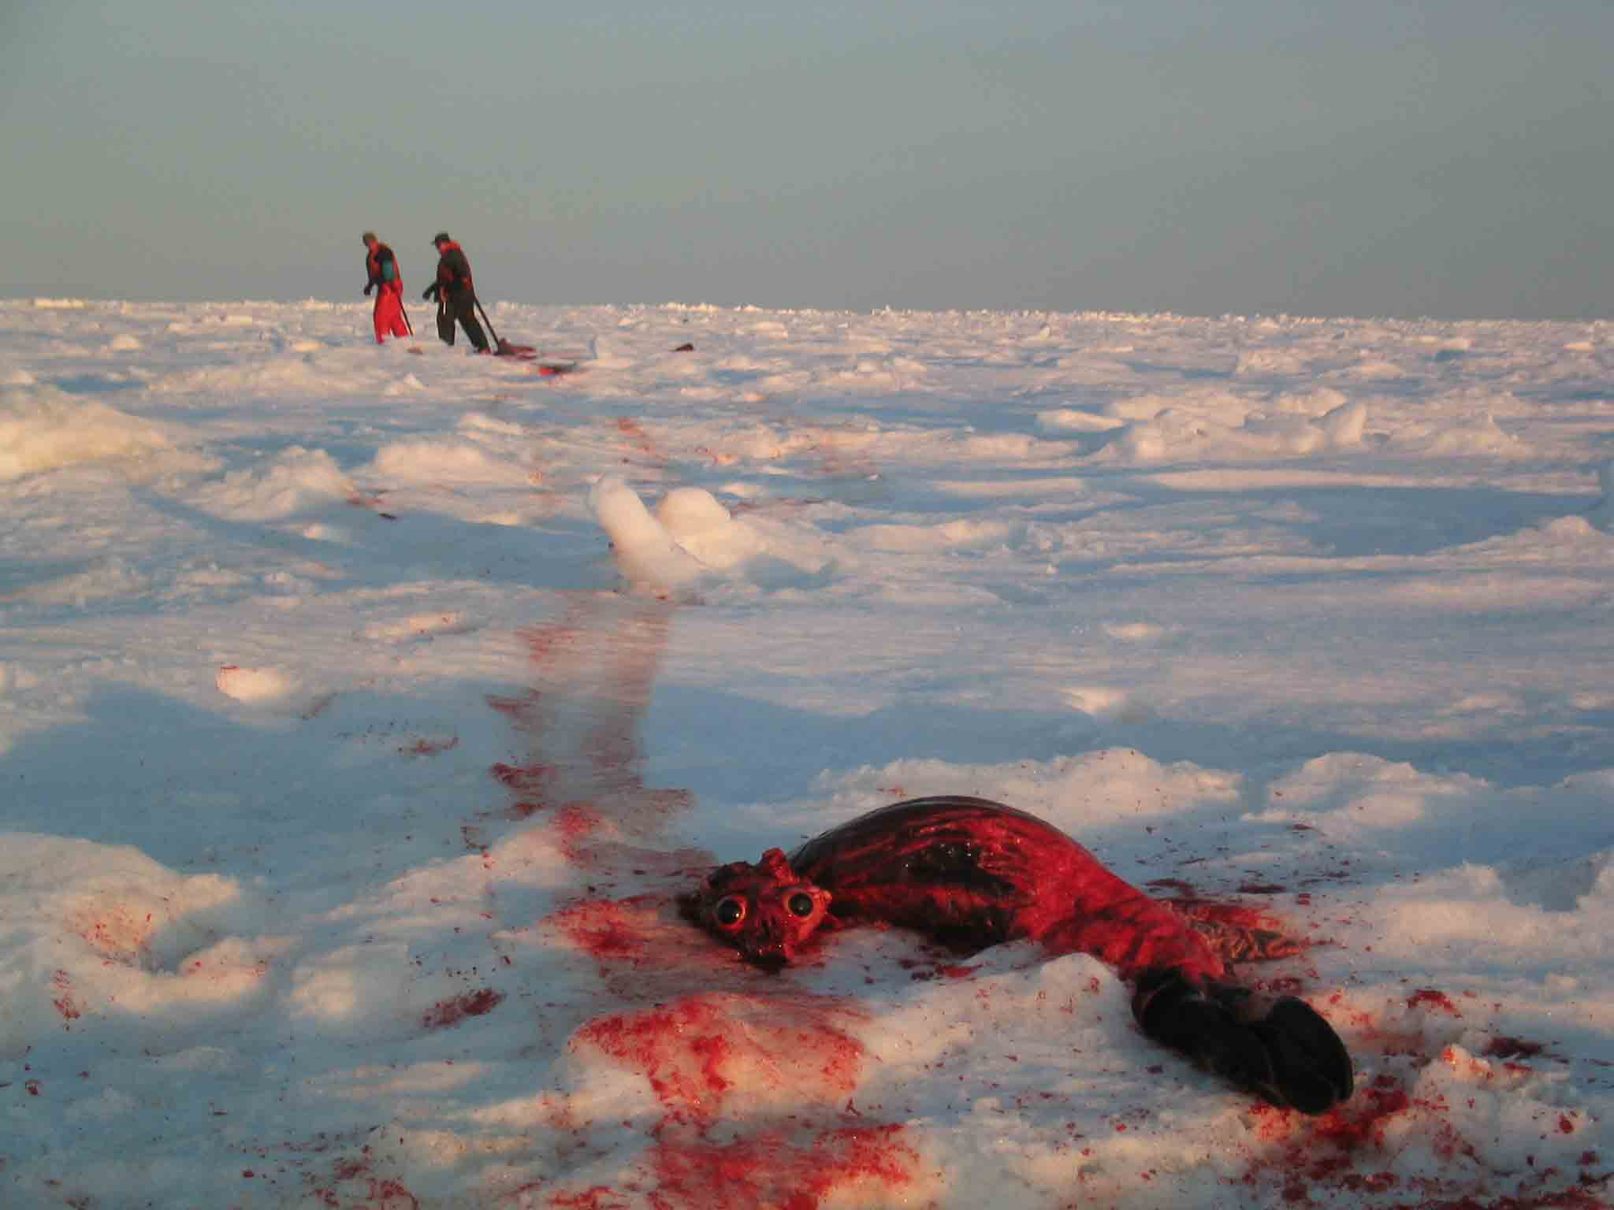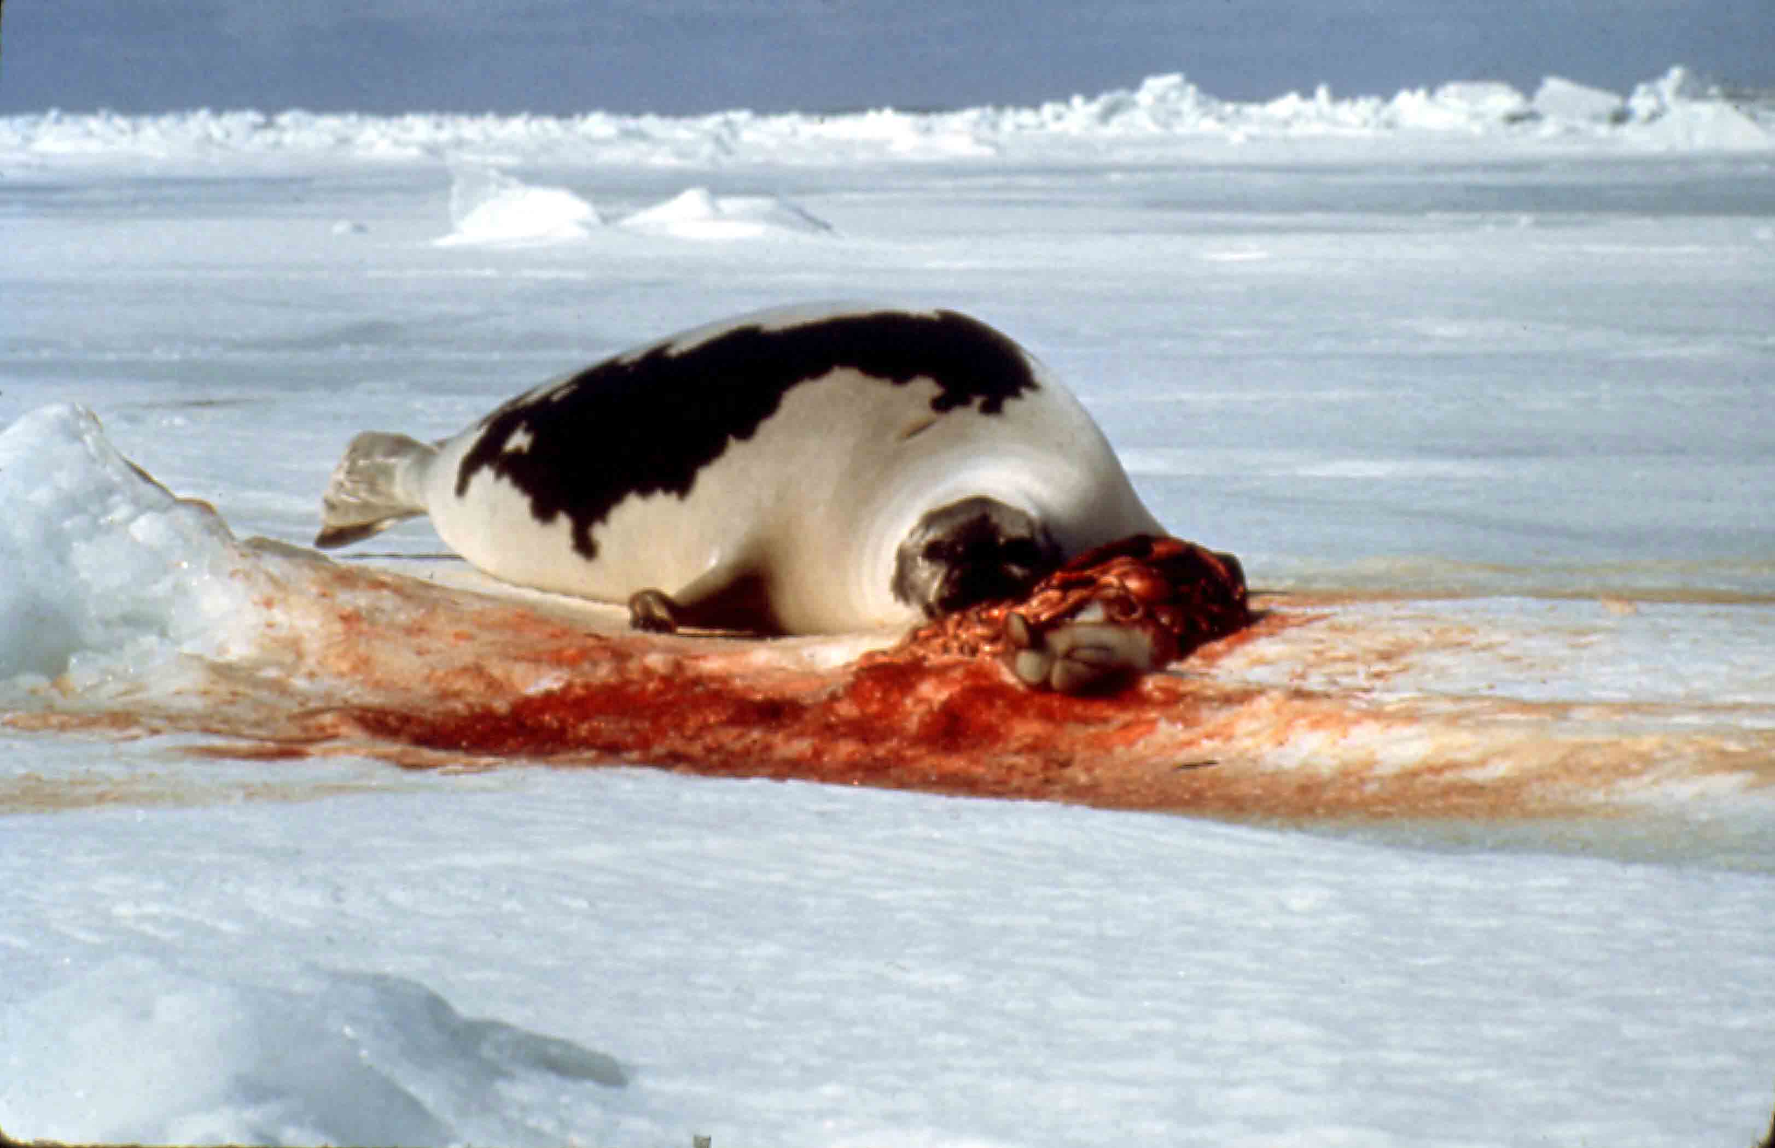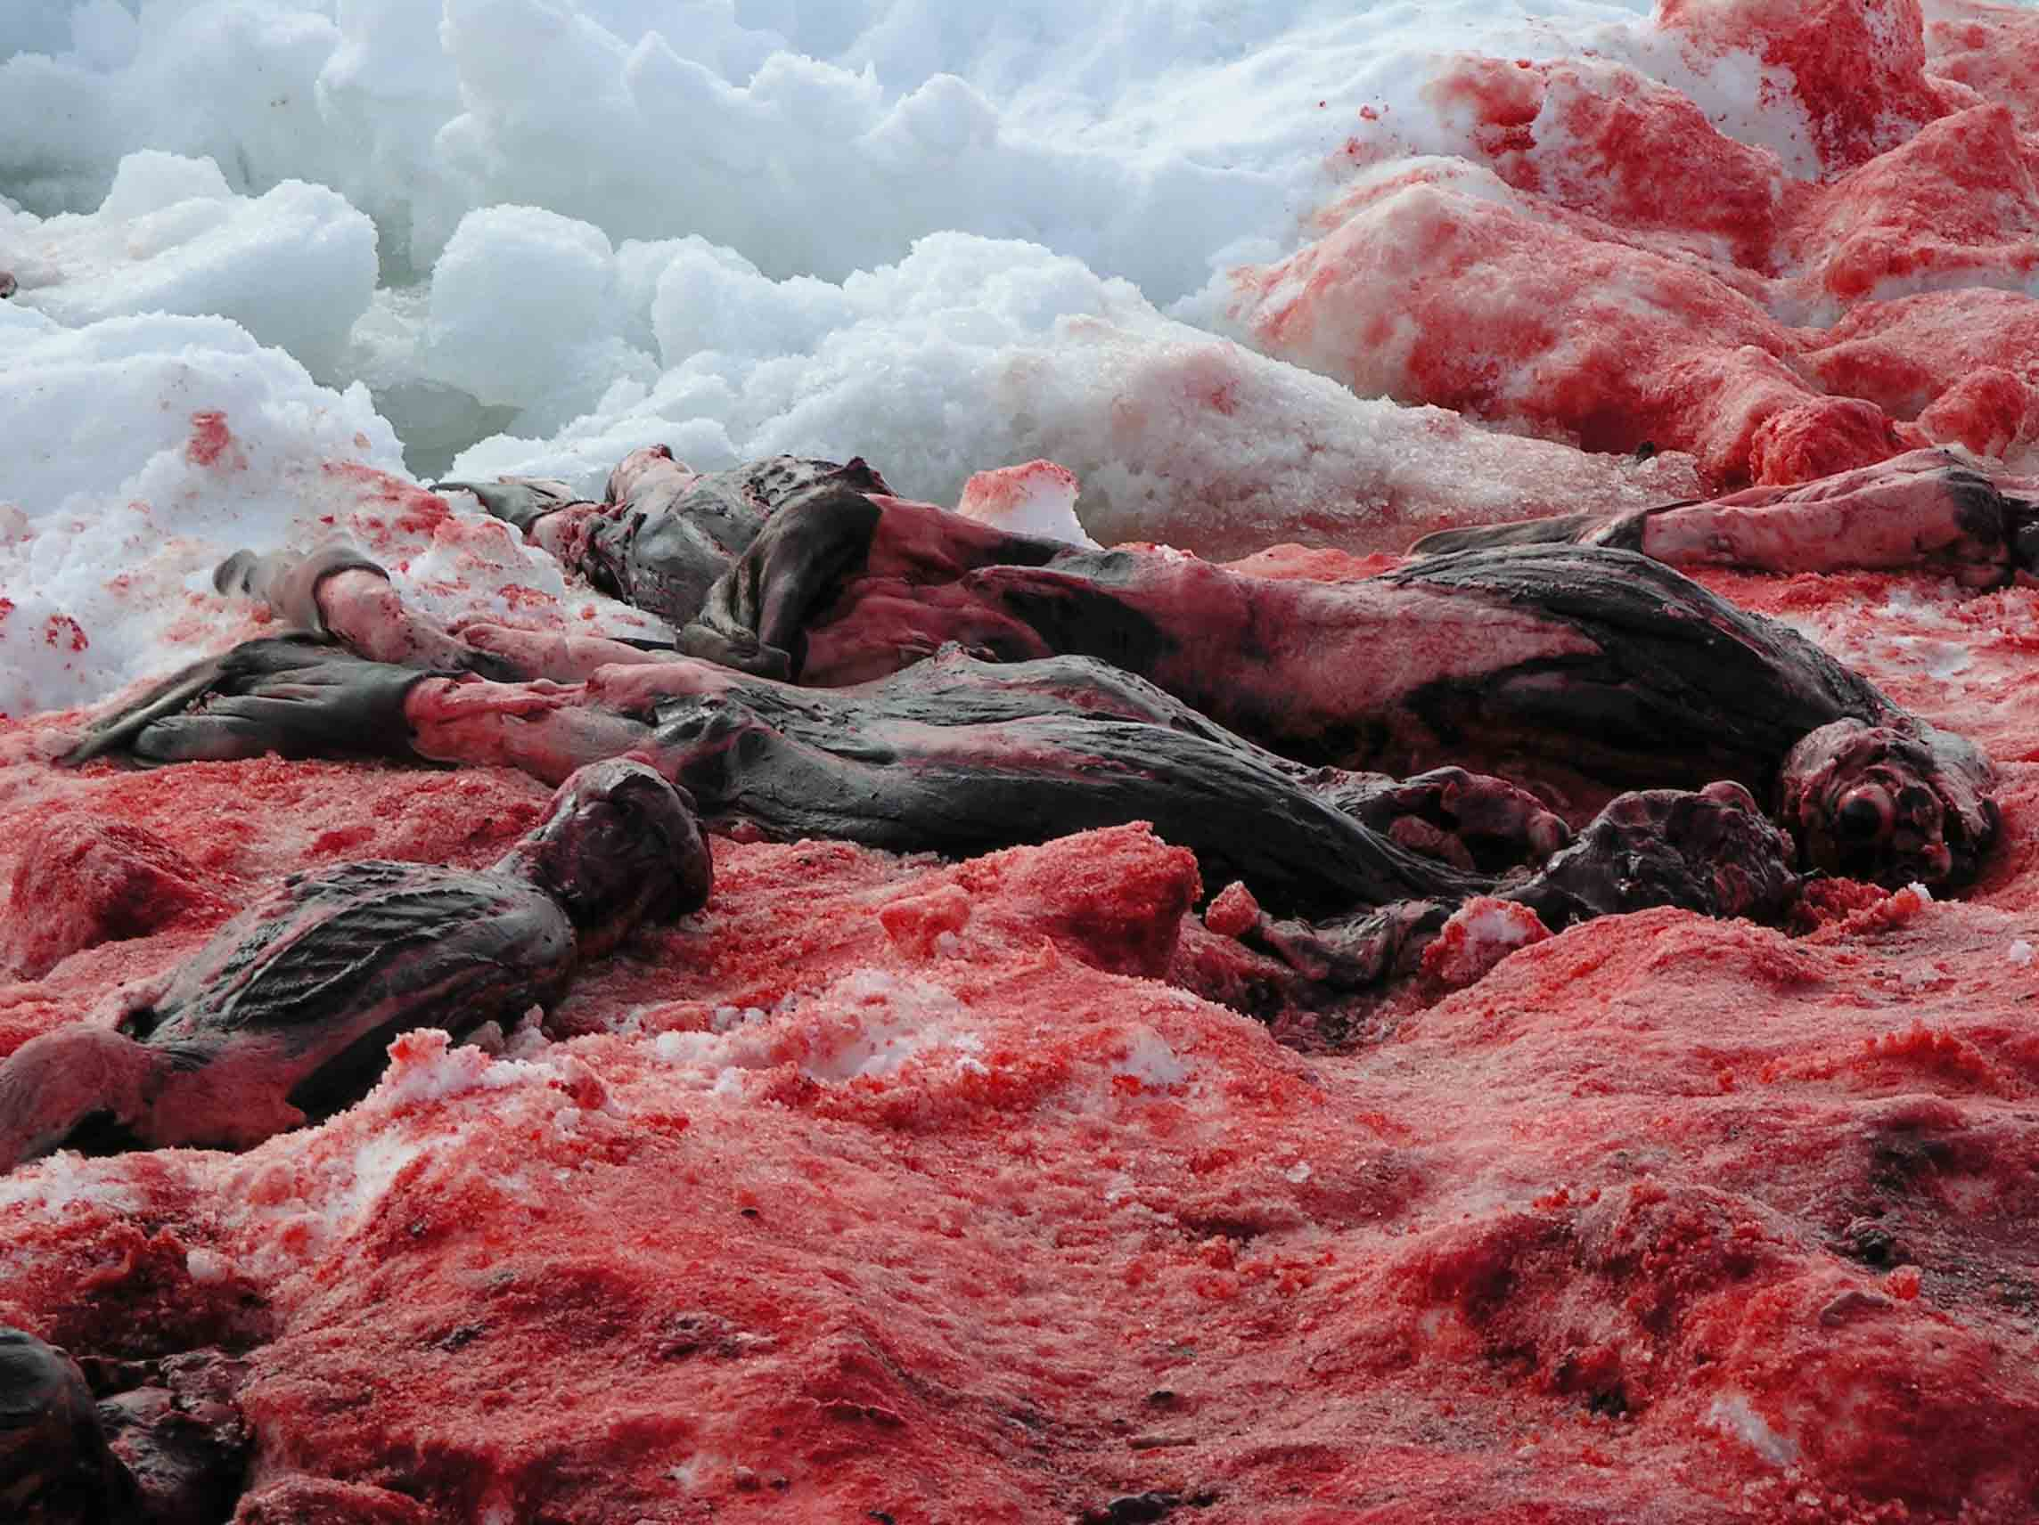

Cracking ice at sealers bloody pathways soaking red
A harp seal’s mother near the poor remains of her baby dead
Its plundered fur on the bloody catwalk of Prada, Dolce & Gabana
Sins of jet set and people’s ignorance to enter into nirvana

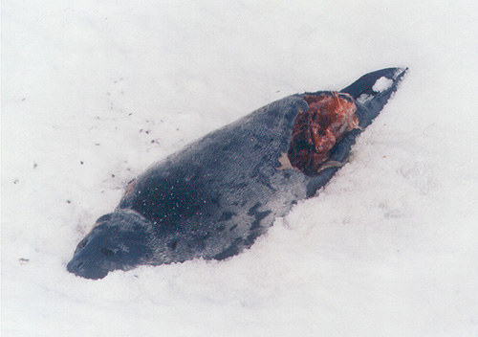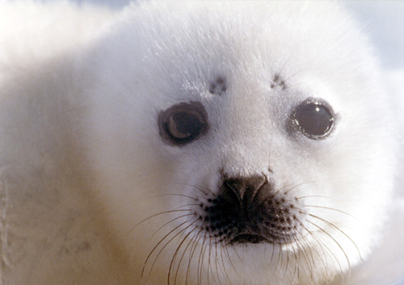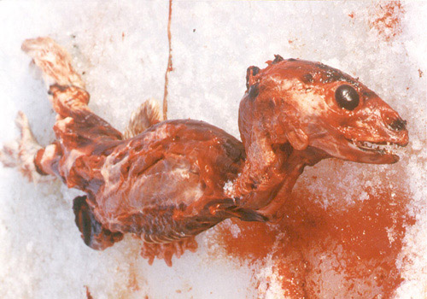

A *beater’s penis cut off while alive in helpless pain
To cure superstitious Asian impotence with sealers’ dirty income is in vain
Baby seal eyes to witness its own body skinned
Not by devils – but officers and sealers at violations just grinned

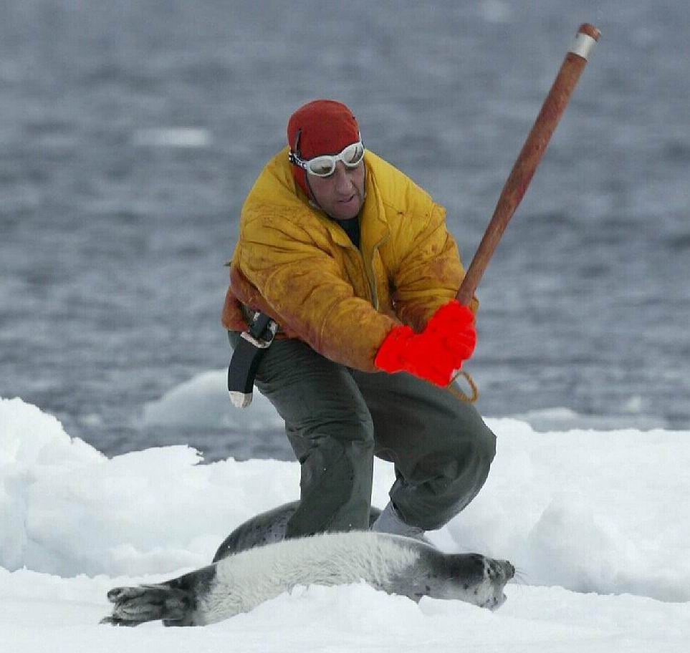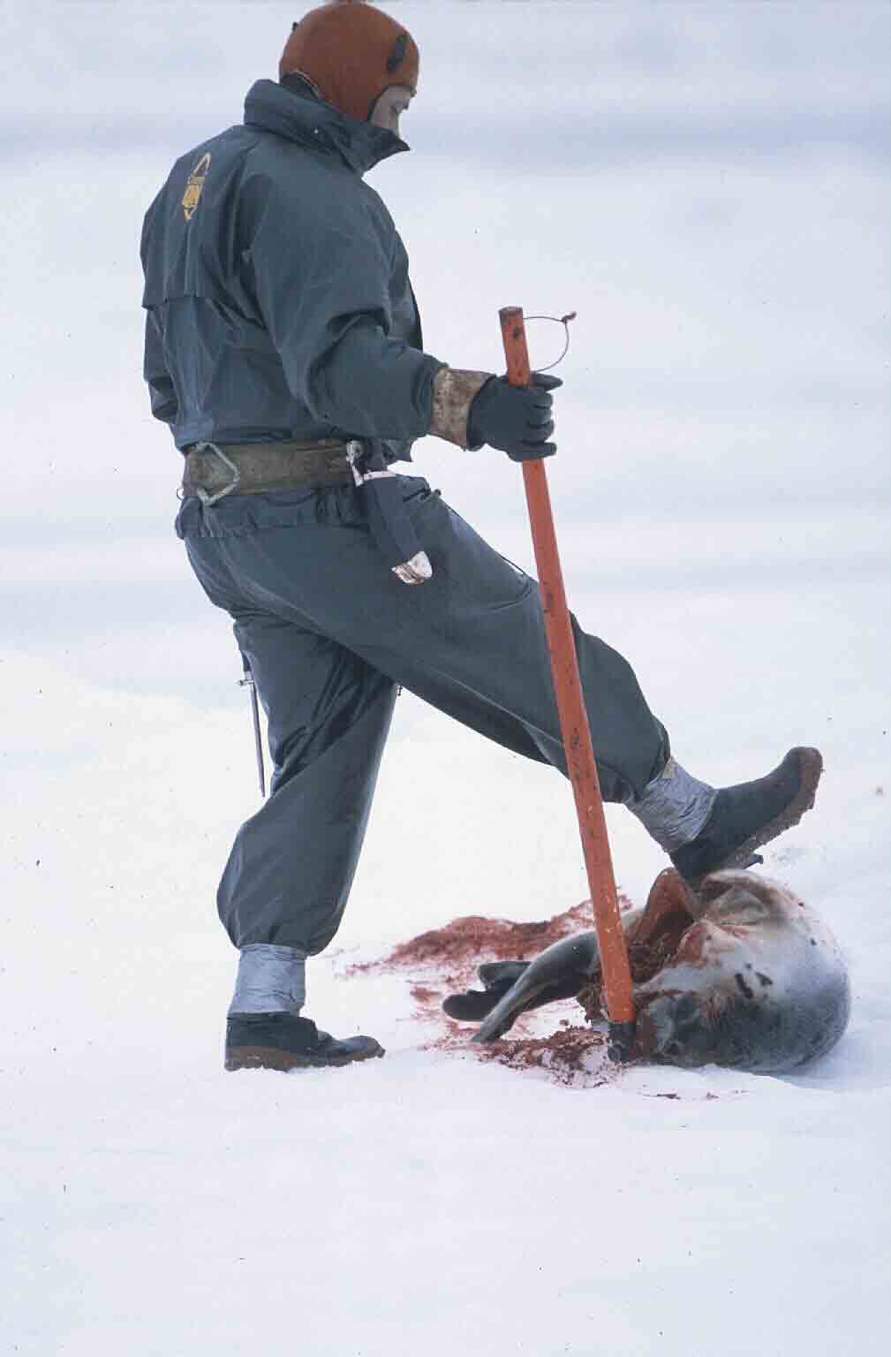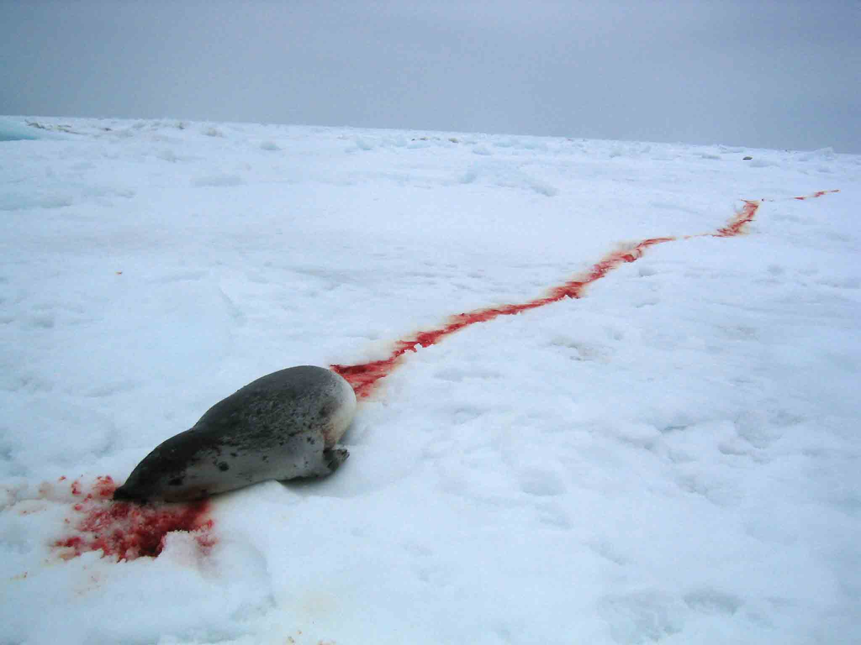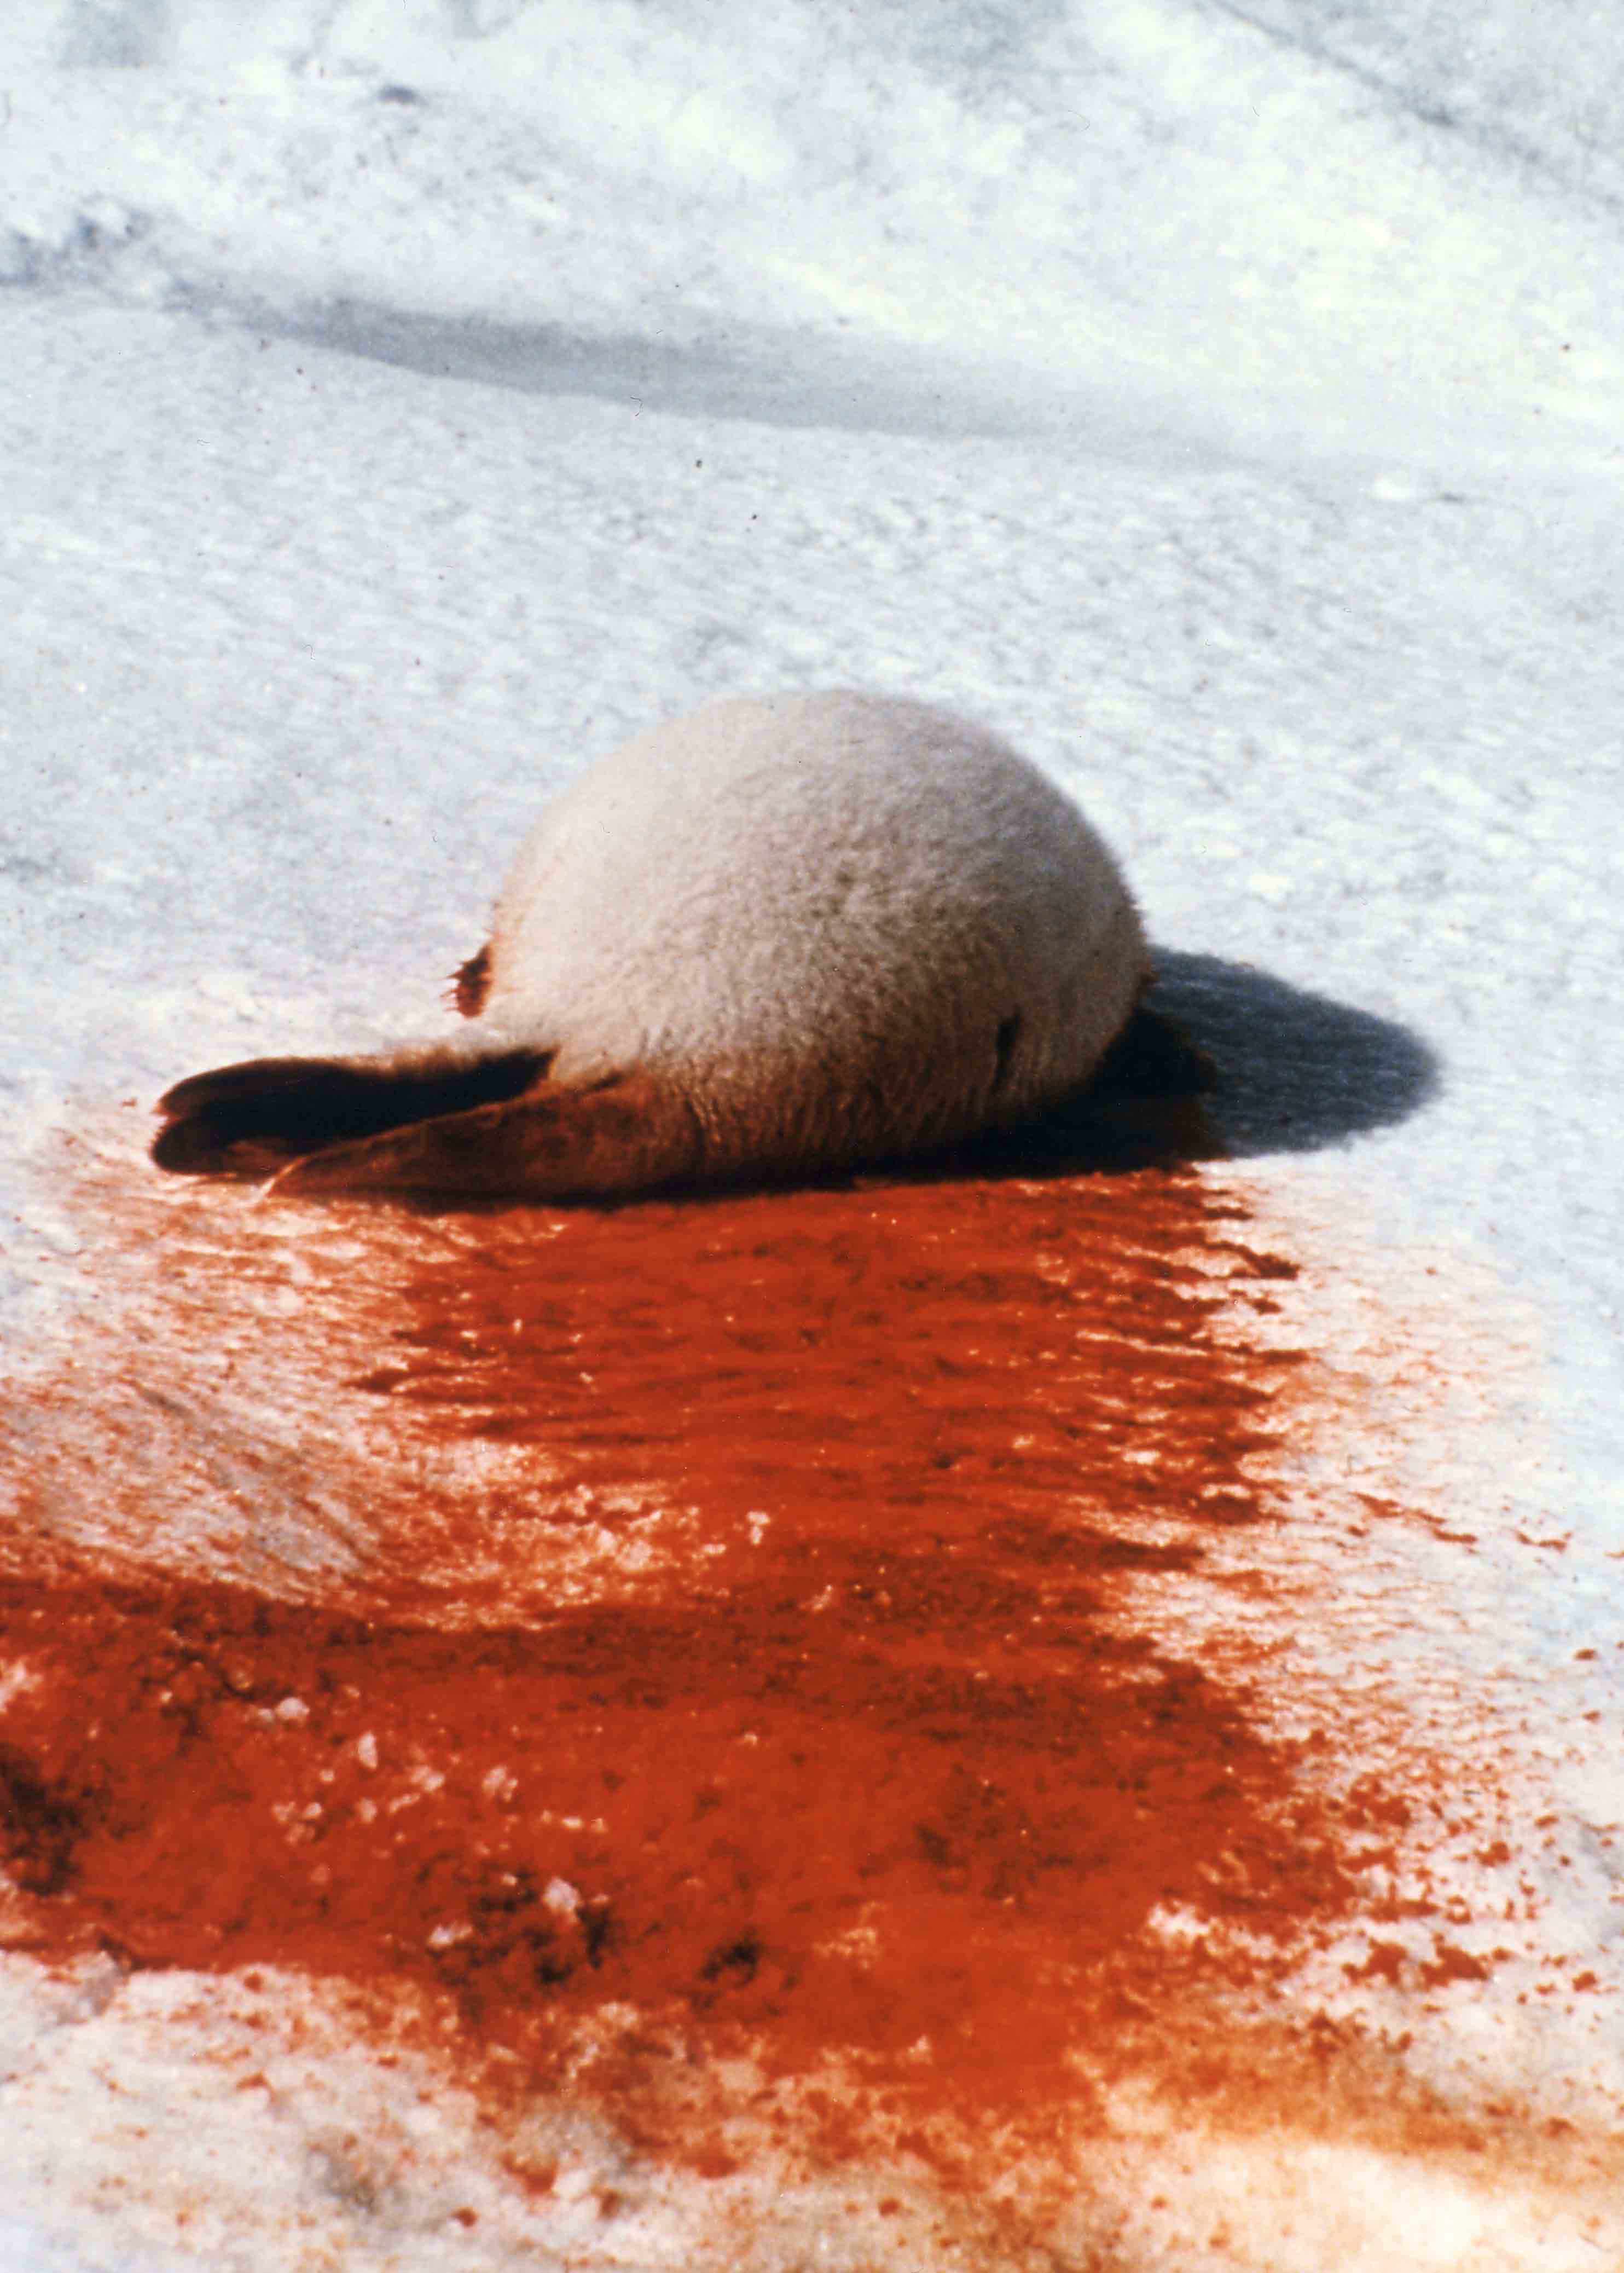

Newfoundland’s cruel slaughter of helpless young seals in masses of a 1 000 000
Subsidized brutal hands to club baby skulls with a tax payer’s million
Lasting strong protest as red bloody trails on ice don’t lie
To fight ruthless massacre – in blood on ice seal babies die

* beater is a grey harp seal baby that shed its embryo hair

