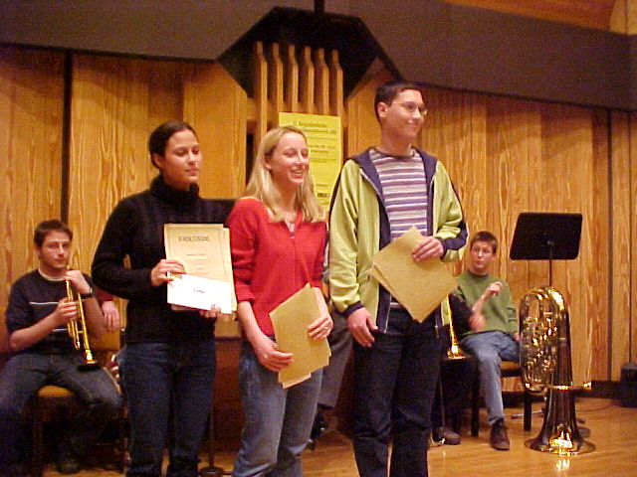

1. Eva Séregély (BG/BRG/BORG Oberschützen),
2. JohannesVarga (BG/BRG/BORG Neusiedl),
3. Barbara Titz (BG/BRG/BORG Eisenstadt).

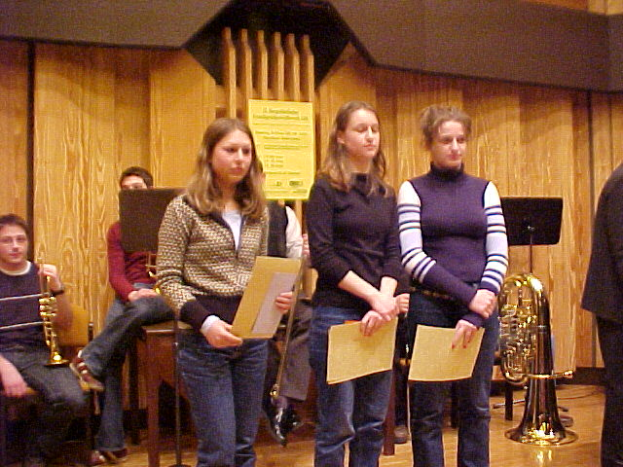

- Lydia Kern (BORG/BARG Jennersdorf)
- Birgit Zirngast (BORG/BARG Jennersdorf)
- Kerstin Knebl (BORG Güssing)

