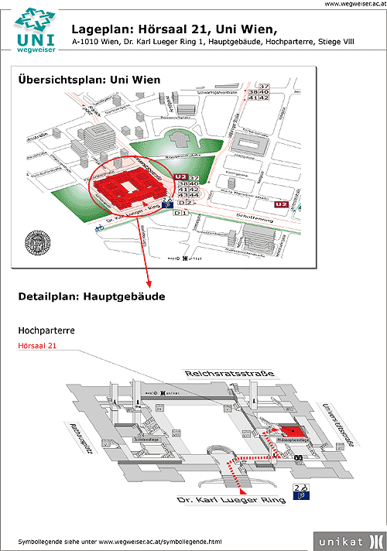
The red colour marks the lecture room of the Department of Classical Philology, Medieval and Neolatin Studies. On the right side of it you find the rooms of the Department where we will meet.
You can get to the Department through a smaller entrance on the right edge of the building.

